

COVID-19 Vaccine Management

|  |
| --- |
| Overview This procedure describes the processes required to safely and effectively manage COVID-19 vaccine procurement, storage, transport, distribution and preparation within the Western Health (WH) COVID-19 Vaccine Hub. |
| Applicability This procedure applies to all WH staff involved in the procurement, storage, transport and distribution of the COVID-19 vaccine, as well as preparation for administration.  This includes pharmacy procurement staff responsible for raising purchase orders and receiving COVID-19 vaccine stock in Merlin Software; the COVID-19 vaccine pharmacy workforce responsible for stock management and maintaining the supply chain to the vaccination clinics; and all pharmacy and nursing staff who may participate in the preparation of the vaccine prior to its administration.  **This procedure incorporates the management of the Pfizer age 12+, Pfizer age 5-11, AstraZeneca, Moderna and Novavax COVID-19 vaccines at the time of writing.** |
| Responsibility The Director of Pharmacy is responsible for introducing and implementing this procedure into practice and for ensuring that the associated forms are finalised and circulated.  The COVID-19 Vaccine Pharmacy Project Officer or delegate(s) are responsible for ensuring that their staff are aware of and comply with the requirements of this procedure.  The appropriate Unit Manager(s) / Project Lead(s) are responsible for ensuring that any nursing staff involved in preparation of the COVID-19 vaccine are aware of and comply with the requirements of this procedure. |
| Authority Exceptions to the practices described in this procedure can only be authorised by the Director of Pharmacy.  Changes to this procedure based on updates to Australia’s COVID-19 vaccine national roll-out strategy or Victorian government requirements may be made without the WH Drug & Therapeutic Committee’s specific endorsement.  Changes outside of these directives require the committee’s endorsement before publication in line with *OP-GC7 Policy and Procedure/Guideline Framework - Operation*. |
| Associated Documentation In support of this procedure, the following Manuals, Policies, Instructions, Guidelines, and/or Forms apply:   |  |  | | --- | --- | | Code | Name | | OP-GC3 | Aseptic Non-Touch Technique (ANTT) | | OP-GC5 | Hand Hygiene | | | OP-GC5 | Needle Stick Injury and Body Fluid Exposure Management | | | OP-GC6 | Medication Prescription, Supply, Storage and Administration | | | OP-GC6 | Medication Refrigeration | | | OP-GC7 | Policy and Procedure/Guideline Framework - Operation | | | Pharmacy SOP SPE4 | Pharmacy Medication Refrigeration and Response | | Pharmacy SOP STORE-1 | Pharmaceutical ordering, receipt and invoice processing | |  | GCCS Shipper Loading procedure – located in COVID 19 Vaccination - Pharmacy Resource Folder (JKSAT Pharmacy) | | Form | [Quarantined Medications Following Temperature Excursion - For Medicines Information](http://inside.wh.org.au/departmentsandservices/Pharmacy/Documents/Quarantined%20Medications%20Following%20Temperature%20Excursion%20-%20for%20Medicines%20Information.xls) | |  | [National Vaccine Storage Guidelines - Strive for 5](https://www.health.gov.au/resources/publications/national-vaccine-storage-guidelines-strive-for-5) | |
| Credentialing Requirements The Senior Education Pharmacist will ensure that pharmacy staff have completed the required training to perform the processes outlined in this procedure.  The appropriate Nurse Educator will ensure that nursing staff have completed the required training to perform the processes outlined in this procedure. |
| Definitions and Abbreviations7.1 Definitions For purposes of this procedure, unless otherwise stated, the following definitions shall apply:   |  |  | | --- | --- | | **Authorised staff member** | Pharmacy staff (pharmacist and pharmacy technician), vaccination nursing staff and medical officer. | | **Breach of cold chain or temperature excursion** | Exposure of vaccines to temperature outside the recommended range of 2 to 8°C.  For Pfizer age 12+ and Pfizer age 5-11 vaccines: When the temperature of the ultra-low medication freezer is found to be outside of the recommended temperature range of -90 to -60°C | | **Cold chain** | The system of transporting and storing vaccines within the safe temperature range of 2 to 8°C. | | **Pfizer age 12+ COVID-19 Vaccine** | BioNTech (BNT162b2 mRNA) COVID-19 VACCINE 30 micrograms/0.3 mL concentrated suspension for injection vial | | **Pfizer age 5-11 COVID-19 Vaccine** | COMIRNATY (Tozinameran) COVID-19 VACCINE 10 micrograms/0.2 mL concentrated suspension for injection vial | | **Cryogenic gloves** | Insulated gloves to protect hands and arms from contact with ULT freezer or dry ice. | | **Multi-dose vial** | A medication vial that contains more than one dose of medication. | | **Nuvaxoid® COVID-19 Vaccine (Novavax)** | Novavax (SARS-CoV2 rS NVX-CoV2373) Covid-19 vaccine | | **Spikevax® COVID-19 Vaccine (Moderna)** | Moderna (Elasomeran) COVID-19 vaccine. | | **(Temperature) data logger** | A small electronic device that continuously measures temperatures and keeps a record of the results. HLP Medi-Log® II is the preferred data logger device; if unavailable another Pharmacy-endorsed device may be used, e.g. Logtag®. | | **Ultra-low temperature (ULT) thermal shipper** | Insulated container with dry ice, used to ship Pfizer-BioNTech COVID-19 vaccines from the manufacturing site/warehouse to vaccination hub sites at ultra-low temperature (-90oC to -60oC). | | **Ultra-low temperature (ULT) Freezer** | Freezer that maintains vaccines at ultra-low temperature (-90oC to-60oC). | | **Vaxzevria® COVID-19 Vaccine (AstraZeneca)** | AstraZeneca (ChAdOx1-S vaccine) COVID-19 Vaccine. | | **Western Health (WH) COVID-19 Vaccine Hub** | One of the nine COVID-19 vaccination hubs established in major metropolitan and regional hospitals in Victoria to manage the COVID-19 vaccine in the national COVID-19 vaccination program. |  7.2 Abbreviations For purposes of this procedure, unless otherwise stated, the following abbreviations shall apply:   |  |  | | --- | --- | | ANUM | Associate Nurse Unit Manager | | BMS | Building Management System | | COVID-19 | CoronaVIrus Disease of 2019 (the disease caused by the novel coronavirus SARS-CoV2) | | CVMS | COVID-19 Vaccine Management System | | CVAS | COVID 19 Vaccines Ordering System | | DH | Department of Health | | DHL | Logistics company | | JKSAT | Joan Kirner Satellite Pharmacy | | NIC | Nurse in Charge | | NUM | Nurse Unit Manager | | PPE | Personal Protective Equipment | | RACF | Residential Aged Care Facility | | SH | Sunshine Hospital | | SOP | Standard Operating Procedure | | ULT | Ultra-Low Temperature | | UM | Unit Manager | | VOC | Vaccine Operations Centre | | VVCC | Victorian Vaccine Control Centre | | WH | Western Health | |  |  | |
| Procedure DetailIndexCOVID-19 VACCINE GENERAL INFORMATION AND SECURITY [8.1 Presentation of COVID-19 Vaccines](#_8.1._Presentation_of)  [8.2 Security of COVID-19 Vaccines](#_8.2_Security_of_1) ORDERING, RECEIPT, STORAGE AND TRANSPORT: WH COVID-19 VACCINE HUB [8.3 Ordering and Receipting COVID-19 Vaccine Stock at JKSAT Pharmacy](#_8.3__Ordering)  [8.4 Handling and Storage of Pfizer age 12+ and Pfizer age 5-11 COVID-19 Vaccine](#_8.4__Handling)s  [8.5 Safe Handling of Dry Ice](#_8.5:_Safe_Handling)  [8.6 Action in the Event of a ULT Freezer Temperature Excursion](#_8.6_Action_in)  [8.7 Handling and Storage of AstraZeneca, Moderna and Novavax COVID-19 Vaccines](#_8.7__Handling) ORDERING, RECEIPT AND STORAGE: CLINIC SITES [8.8 Transporting COVID-19 Vaccines from JKSAT Pharmacy to Clinic Sites](#_8.8__Transporting)  [8.9 Packaging of COVID-19 Vaccines for Courier Transport](#_Packaging_of_COVID-19)  [8.10 Vaccine Pharmacist Receiving COVID-19 Vaccine at Clinic Sites](#_8.10__Vaccine)  [8.11 Reconciliation of COVID-19 Vaccine Stock Levels at Clinic Sites](#_8.11__Reconciliation)  [8.12 Ordering of Vaccines at Clinic Site from JKSAT Pharmacy](#_8.12__Ordering)  [8.13 After Hours Fridge Alarm Notification at Melton Vaccination Clinic Site](#_8.13__After) DILUTION, DOSE PREPARATION AND STOCK WASTAGE [8.14 Workstation Preparation (Pfizer age 12+ or Pfizer age 5-11 or AstraZeneca or Moderna or Novavax COVID-19 Vaccine)](#_8.14__Workstation)  [8.15 Dilution of Pfizer age 12+ COVID-19 Vaccine](#_8.10_Dilution_(Pfizer-BioNTech)  [8.16 Dose Preparation from Diluted Pfizer age 12+ COVID-19 Vaccine Vial](#_8.16__Dose)  8.17 [Dilution of Pfizer age 5-11 COVID-19 Vaccine](#_8.10_Dilution_(Pfizer-BioNTech)  [8.18 Dose Preparation from Diluted Pfizer age 5-11 COVID-19 Vaccine Vial](#_8.18_Dose_Preparation" \o "Melton manufacturing Card Pfizer COVID-19 - 4.11.21 - Copy" \t "Melton manufacturing Card Pfizer COVID-19 - 4.11.21 - Copy)  [8.19 Dose Preparation from AstraZeneca COVID-19 Vaccine Vial](#_8.17__Dose)  [8.20 Dose Preparation from Moderna COVID-19 Vaccine Vial](#_8.18__Dose)  8.21 Dose Preparation from Novavax COVID-19 Vaccine Vial  [8.22 Labelling the COVID-19 Vaccine Syringe](#_8.18__Labelling_1)  [8.23 Stock Wastage](#_8.19__Stock) APPENDICES [1. WH COVID-19 Vaccine Stock Recording Form (FREEZER/REFRIGERATORS)](#_Appendix_1:_WH)  [2. WH COVID-19 Vaccine Stock Recording Form at Clinic](#_Appendix_2_WH)  [3.](#_Appendix_3_Storage) [Pfizer-BioNTech COVID-19 Vaccine Room Temperature Exposure Label](#_Appendix_3_Pfizer-BioNTech)  [4. PPE required when Handling Dry Ice and Vaccines Stored in ULT Conditions](#_Appendix_4_1)  [5. COVID-19 Vaccine Transportation Label](#_Appendix_5:_Pfizer-BioNTech)  [6. Label for Quarantined Temperature Excursion Stock](#_Appendix_6:_Label)  [7.](#_Appendix_7:_WESTERN) [Temperature Monitoring Form for Freezers (-80⁰C and -20⁰C)](#_Appendix_7:_Temperature)  [8. ULT Freezer Schedule, Transaction & Temperature Log](#_Appendix_8_1)  [9. WASTED or DISCARDED COVID-19 VACCINE SYRINGE AND VIAL Recording Tool](#_Appendix_9_)  [10. COVID-19 Vaccine Order Form](#_Appendix_14)  [11. Manufacturing Cards for COVID-19 Vaccines](#_Appendix_10)  [12. Pharmacy Daily Log](#_Appendix_12_PHARMACY)  [13. FREEZER MAP](#_Appendix_13:_FREEZER)  [14. TIVE 5 Logger](#_Appendix_14:_TIVE)  [15. Coldtainer – for vaccine storage at remote vaccination sites (e.g. RACF)](#_Appendix_15:_Coldtainer) COVID-19 VACCINE GENERAL INFORMATION AND SECURITY8.1. Presentation of COVID-19 Vaccines **Pfizer aged 12+ COVID-19 Vaccine (purple-cap vial):**   * Is a concentrated, white to off-white frozen suspension for injection (sterile concentrate). * Is a multidose vial and must be diluted before use. * Is supplied in packs containing 195 vials: * Each vial (0.45 mL) contains 6 doses of 0.3 mL after dilution. * Each dose (0.3 mL) contains 30 micrograms of BNT162b2 [mRNA] (embedded in lipid nanoparticles). * Should be stored at 2°C to 25°C after dilution and used within 6 hours.   **Pfizer age 5-11 COVID-19 Vaccine (orange-cap vial):**   * Is a concentrated, white to off-white frozen suspension for injection (sterile concentrate). * Is a multidose vial and must be diluted before use. * Is supplied in packs containing 10 vials:   + Each vial (1.3mL) contains 10 doses of 0.2 mL after dilution.   + Each dose (0.2 mL) contains 10 micrograms of COVID- mRNA vaccine (embedded in lipid nanoparticles). * Should be stored at 2°C to 30°C after dilution and used within 12 hours.   **AstraZeneca COVID-19 Vaccine:**   * Is a colourless to slightly brown, clear to slightly opaque liquid. * Is supplied in packs of 10 vials: * Each vial contains 8 doses (4 mL) or 10 doses (5 mL).   **Moderna COVID-19 Vaccine:**   * Is a white to off-white suspension. * Is supplied in packs of 10 vials: * Each vial contains 10 doses (5 mL). * Unpunctured vials may be held at room temperature for up to 24 hours.   **Novavax COVID-19 Vaccine:**   * Is a colourless to slightly yellow, clear to mildly opalescent suspension * Is supplied in packs of 10 vials: * Each vial contains 10 doses (5mL).  8.2 Security of COVID-19 vaccines The following safeguards must be followed to ensure security of COVID-19 vaccines:   * In pharmacy, COVID-19 vaccines are stored in the locked ULT freezer and vaccine refrigerators:   + Keys are accessible only to the Vaccine Pharmacist and SH Deputy Director of Pharmacy during normal working hours.   + Keys are stored in the JKSAT key safe and accessible to the on-call pharmacist out of hours, so that they may respond to temperature breaches.   + The master key will be stored in the SH Deputy Director of Pharmacy’s office key safe. * At vaccination clinics, COVID-19 vaccines are stored in the locked clinic vaccine refrigerators, with keys accessible only to the Vaccine Pharmacist. * Packages of COVID-19 vaccines for delivery from the vaccine hub site are sealed with tamper-evident tape so that any tampering can be easily identified. * All COVID-19 vaccine stock transactions: * In pharmacy are recorded on the WH COVID-19 Vaccine Stock Recording Form (FREEZER/REFRIGERATORS) ([Appendix 1](#_Appendix_1_WH)) by the Vaccine Pharmacist with a second authorised staff member, except in circumstances where only one authorised staff member is available.   NOTE: If only one authorised staff member is available to sign for a transaction, two authorised staff members must carry out a balance check as soon as practicable.    *Also see* [*Section 8.3*](#_8.3__Ordering) *for stock management processes.*   * + At the vaccination clinic are recorded on the WH COVID-19 Vaccine Stock Recording Form at Clinic ([Appendix 2](#_Appendix_2_WH)) by two authorised staff members.   + Must be documented on a separate form for each brand of vaccine. * The balance of COVID-19 vaccine stock must be checked daily. * Once wastage of vials has been recorded in the pharmacy or vaccination clinic recording tools, two staff members will dispose of the wasted vials in a sharps bin, so that they cannot be retrieved (see Section [8.23](#_8.23__Stock)).  ORDERING, RECEIPT, STORAGE AND TRANSPORT: WH COVID-19 VACCINE HUB8.3 Ordering and Receipting COVID-19 Vaccine Stock at JKSAT Pharmacy The nominated COVID-19 Vaccine Pharmacist at JKSAT Pharmacy is responsible for the daily stock management of COVID-19 vaccines. This includes acceptance, storage, handling, distribution, reconciliation, disposal, managing cold chain breaches and performing the administrative duties in the CVMS and CVAS  The Vaccine Pharmacist (or delegate) is responsible for the following tasks to ensure that the Vaccine Operation Centre (VOC) has the correct information regarding the stock availability at the WH COVID-19 Vaccine Hub:   * Checking and reconciling physical stock in the JKSAT Pharmacy daily. * Completing the Vaccine Delivery Acceptance, Stock Management and Wastage Report in the Commonwealth’s CVAS online portal.   **Important:** The VOC requires the process of vaccine acceptance, stock management and stock wastage to be reported back to the Commonwealth in a timely manner.  The Vaccine Pharmacist, together with the COVID-19 Vaccine Pharmacy Project Officer, must ensure reporting is complete promptly. 8.3.1 Ordering COVID-19 Vaccine Stock COVID-19 vaccine stock ordering for the WH COVID-19 Vaccine Hub is performed by the DH, according to the hub’s vaccine usage and stock availability. 8.3.2 Receiving COVID-19 Vaccine Stock The COVID-19 Vaccine Pharmacy Project Officer will receive prior notice of delivery times of COVID 19 Vaccines from the DHL control tower and will ensure that:   * Two staff members are available to perform the task of receiving COVID 19 vaccines. * Different brands of COVID-19 vaccine are stored separately.   After removal from the shipper box:   * Pfizer age 12+ and Pfizer age 5-11 COVID-19 Vaccines are to be transferred immediately to the ULT freezer. See [Section 8.4](#_8.4_Storage_and) for details. * AstraZeneca COVID-19 Vaccine is to be transferred immediately to the 2 - 8◦C refrigerator. * Moderna COVID-19 Vaccine is to be transferred immediately:   + to the -25°C to -15°C Freezer, if transported frozen;   + to the 2 - 8◦C refrigerator, if transported thawed in liquid state at 2°C to 8°C. See [Section 8.7.2](#_8.7__Handling) for details. * Novavax COVID-19 Vaccine is to be transferred immediately to the 2 - 8◦C refrigerator. * The receiving Vaccine Pharmacist will: * Check the labelling on the packages to ensure that the items are being delivered to the correct location. * Inspect stock to ensure that the quantity and batch number are correct and that no tampering or damage to the package are evident. * Endorse the following on the delivery note:   + - Signature of the receiving pharmacist;     - Date and time of delivery; and     - ‘Correct quantity received’ if the order received is correct. * Review the temperature data logger to ensure that no temperature breaches occurred during transit:   + - Download the TEMPTALE® pdf and ttv and save under S:\pharmacy1\COVID 19 Vaccination Project\Completed Commonwealth Forms\Acceptance Form\     - Print the pdf temperature report; and     - Endorse ‘Received in good condition’ if no temperature excursion noted. * Perform CVMS ‘Batch Delivery’ transaction. * Complete the Vaccine Delivery Acceptance in CVAS online portal no later than 9pm (local time) on the day of delivery: * Complete the ‘WH COVID 19 Vaccine Stock Recording form (FREEZER/REFRIGERATORS) ([Appendix 1](#_Appendix_1)) and for Pfizer vaccines, the ULT Freezer Schedule, Transaction & Temperature Log ([Appendix 8](#_Appendix_8_1)). * File a copy of the delivery note and save the TEMPTALE® pdf file in the ‘COVID 19 Vaccine Completed Forms’ folder. * Send the original delivery note to the purchasing officer.   **Any issues with stock delivered must be reported to the DHL Supply Chain Control Tower (Ph: 1300 279 498) as soon as practicable and the VOC must be notified within 2 hours of the delivery.** 8.3.3 Processing Receipt of COVID-19 Vaccine Stock in Merlin The Vaccine Pharmacist must send the original copy of the COVID 19 vaccine delivery note to the Purchasing staff as soon as practical.  Purchasing staff must complete the Merlin Stock Receipt Process (refer to Section 8.5.1 of Pharmacy SOP: STORE-1 Ordering, Receipt and Invoice Processing of Pharmaceuticals).  **8.3.4 Transfer of Excess Vials** The DH has approved the transfer of excess vaccine vials from agencies appointed by the Commonwealth to provide immunisation services to the nearerst COVID-19 Vaccine Hub. The process aims to facilitate transfer and reduce wastage (see figure 1). All deliveries will occur prior to 16:00 hours (Monday – Friday).  Note: The JKSAT Vaccine Pharmacist is not required to complete the Commonwealth’s Online Acceptance form with this shipment receipt.  **Figure 1: Process for Transfer of Excess Vials**   |  |  |  | | --- | --- | --- | | **PROCESS FOR TRANSFER OF EXCESS VIALS FROM EXTERNAL AGENCIES TO JKSAT PHARMACY** | | | | **STEP** | **OWNER** | **PROCESS** | | **1** | VVCC | If excess vials are available and the WH COVID-19 Vaccine Hub is the closest Vaccine Hub, the DH will contact the Project Director and the COVID-19 Vaccine Pharmacy Project Officer and seek provisional approval for the JKSAT Pharmacy to either accept or reject them.  If JKSAT Pharmacy is able to accommodate the excess vials, DH will then send the notification via email and attach the cold chain records (including defrost time(s) where applicable). DH must confirm that delivery will occur prior to 16:00 hours (Monday to Friday). | | **2** | VVCC | The VVCC will log an Our Service Incident Case pending transfer of the excess vaccine vials to the Vaccine Hub Pharmacy. | | **3** | VVCC | The VVCC will forward cold chain records to the COVIDVAX Commissioning and Logistics (Consumables) Team for their review and approval, ensuring cold chain compliance. | | **4** | VVCC | The VVCC will confirm approval of the cold chain record by the Logistics Team with the relevant agencies. | | **5** | VVCC | DH will organise and coordinate delivery of the vaccine vials to the Vaccine Hub Pharmacy, ensuring that data logger(s) and termperature logger records are sent with them and CVMS transfers of vaccine are completed by the external agencies. | | **6** | JKSAT Pharmacy | The JKSAT Vaccine Pharmacist will:   * Confirm receipt of the vaccine vials in good condition and undamaged * Place the vaccine vials in the refrigerator immediately * View the accompanying data logger records and determine that the cold chain has been maintained with no temperature excursion(s) during transit * Sign the delivery note if available or Perform CVMS vaccine “delivered” transaction. * For Pfizer or Moderna vials, attach the corresponding ‘COVID-19 Vaccine Transportation Label’ ([Appendix 5](#_Appendix_5_1)) * Record receipt in WH COVID-19 Vaccine Stock Recording Form (FREEZER/REFRIGERATORS) ([Appendix 1](#_Appendix_1)) | | **7** | VVCC | The VVCC will update the Our Service Incident Case attaching all evidence of documentation received from the Vaccine Hub Pharmacy and close the incident case. |  8.4 Handling and Storage of Pfizer age 12+ and Pfizer age 5-11 COVID-19 Vaccines The vaccine is shipped and stored between -90°C and -60°C, and is packaged with dry ice (see figures 2.1 and 3, below).  While the sealed containers are validated for up to 10 days, there is a permitted window of 5 minutes between removal of the dry ice pod and transfer of the payload or sealed tray(s) into a ULT freezer (-80°C).  **Figure 2.1:** Pfizer age 12+ COVID-19 vaccine trays within the ULT thermal shipper    **Figure 2.2:** Pfizer age 5-11 COVID-19 vaccine vials   8.4.1 Unpacking and transfer process (read [Section 8.5 Safe Handling of Dry Ice](#_8.5:_Safe_Handling) before proceeding):  * Using a trolley, transfer the entire container to an area beside the ULT freezer (-80°C).   *Each box is expected to weigh 37kg – use an upright trolley to transfer.*   * The outer carton must not be opened until the following conditions are met:   + Appropriate PPE is available for donning:     - Cryogenic gloves, aprons and goggles/ face shield ([Appendix 4](#_Appendix_4_1))     - Disposable gloves to wear under the cryogenic gloves.   + A second staff member wearing disposable surgical gloves is available to assist with timely transfer process.   + A stop watch is available.   + It has been confirmed that there is adequate space in the ULT freezer for storage of the new payload(s) by referring to the freezer map ([Appendix 13](#_Appendix_13:_FREEZER)). * Open the lid of the outer carton. * Press the “stop” button on the temperature monitoring device that is located on the inner lid. and hold for 5 seconds. * Disposable **and** cryogenic gloves must be donned before proceeding to open the carton further. * Remove the inner lid and place to one side. * Instruct the second staff member to start the timer in accordance with the specified time dependant on the quantity being received. * Remove the vaccine trays imbedded in the dry ice.:   + Sealed tray(s): Do not open or remove vials; or   + Open trays(s). * Place the vaccine trays into the ULT freezer (-80°C). * Store vials in the original closed-lid vial tray box to protect from light and keep vials upright:   + If any damage to the outer vial tray box is identified **or** if trays are missing, store vial trays in ULT freezer separate to other stock, close and lock ULT freezer door, and immediately notify the VOC. * During the transfer process, the second staff member must be alert to the time, and give a warning when 1 minute from the specified time is approaching:   + **Sealed tray(**s): the vaccine must be transferred from the carton for long-term storage into an ULT freezer (-80°C) within **5 minutes**.   + **Open tray(s):** the vaccine must be transferred from the carton for long-term storage into an ULT freezer (-80°C) within **3 minutes**.   *Each time the ULT freezer is to be opened, the Vaccine Pharmacist must record details in the ULT Freezer Schedule, Transaction & Temperature Log (*[*Appendix 8*](#_Appendix_8_1)*).*  *If the specified time is exceeded, complete the process of transferring and quarantine the stock in the ULT freezer (-80°C). Contact the VOC immediately for further advice.*  *Note: After vaccine trays are placed in an ULT freezer following room temperature exposure, they must remain in the ULT freezer for at least 2 hours to maintain temperature between -90°C to -60°C.*  *This means that there must be a minimum of 2 hours between ULT freezer transactions.*   * Place the inner lid inside the shipper box. * The shipper box will be moved to a secure area in the SH Vaccination clinic for the dry ice evaporation and storage. Refer to **Section 8.5 Safe Handling of Dry Ice**, below. * Once ULT freezer transfers are complete, remove cryogenic gloves and goggles:   + Clean goggles with disinfectant wipe.   + Return cryogenic gloves, goggles, and stopwatch to the workstation next to ULT freezer.   + Discard disposable gloves. * Update the freezer map ([Appendix 13](#_Appendix_13:_FREEZER)) with the location of the new vaccine tray placement.  8.5: Safe Handling of Dry Ice Dry ice is the frozen form of carbon dioxide. When heated, most frozen solids melt to a liquid form, but dry ice transforms directly into a gas (sublimation). Dry ice sublimes at temperatures at or warmer than –78 °C.  The main hazards of dry ice include **asphyxiation** and **cold burns**:   * Use of dry ice in confined spaces (small rooms or walk-in refrigerators) and/or poorly ventilated areas can result in depletion of oxygen, causing asphyxiation. * Exposed skin should be protected from contact with dry ice.   First aid for dry ice burns is the same as for heat burns – treat with tepid running water and seek medical attention.  **Safety information summary:**    **Also refer to the Safety Data Sheet: Carbon Dioxide, Dry Ice (link to file below):**    **Precautions for handling:**     * **Ventilation:**   + At room temperature (including most cold storage temperatures), dry ice becomes carbon dioxide (CO2) gas, which may cause difficulty breathing or suffocation. Carbon dioxide is heavier than air and accumulates in low, poorly ventilated spaces.   + If dry ice has been in a closed area, trailer, or container, open doors and allow adequate ventilation before entering.   + **If you feel short of breath or develop a headache, these may be signs that you have inhaled too much carbon dioxide. Leave the area immediately.**   + A CO2 meter will be placed in the JKSAT Pharmacy to monitor levels. * **PPE to be used when handling dry ice to prevent cold burns (figure 3 and** [**Appendix 4**](#_Appendix_4_1)**):**   + Waterproof insulated cryogenic gloves.   + Safety glasses/goggles with side shields.   + Apron/gown.   Enclosed shoes must also be worn.  **Figure 3:** PPE to be used while handling dry ice:    **Disposal:**   * The dry ice pod from the ULT thermal shipper (Figure 2) must be safely stored in a well-ventilated location with low fire risk to sublimate (turn to carbon dioxide gas):   + **DO NOT leave dry ice in an unsecured area.**   + **DO NOT place in a drain or flush down the toilet.**   + **DO NOT dispose of in waste bins.**   + **DO NOT place in a closed area, such as an airtight container or walk-in refrigerator.** * 20kg of dry ice from a single ULT thermal shipper will take approximately 7 days to sublimate.   Following removal of dry ice from the shipper, apply a blank label to indicate that the thermal shipper container is empty. Emptied thermal shippers and data loggers should be stored in a clean and secure location until collection.   8.6 Action in the Event of a ULT Freezer Temperature Excursion **ULT Freezer temperature monitoring:**   * PHCBI TWINGUARD SANYMDF-DU502VX-PE ULT freezer must be set to run at a -80°C set point: * **The high alarm is set for -65**°C **and low alarm is set at -90**°C for the ULT freezer. * **The high alarm is set for -70**°C **and low alarm is set at -90**°C for the Schneider BMS temperature monitoring. * The BMS will send alarm notification to JKSAT Vaccine Pharmacist mobile (during working hours) or On-call Pharmacist pager (pager #407) and mobile (after hours). * The Vaccine Pharmacist (or delegate) must check the BMS and record the ULT freezer temperature on the Temperature Monitoring Form for Freezers (-80⁰C and -20⁰C) ([Appendix 7](#_Appendix_8)) **FOUR times a day** to confirm the ULT freezer is operating within the acceptable limits and no temperature excursion has occurred.   **In the event of a ULT freezer alarm notification:**   * Review the temperature recording data on the ULT freezer panel and the BMS and action according to the temperature on the freezer panel:   + If the ULT freezer temperature is between -59.9 and -15°C, immediately move the vaccines to the Liebherr -20°C freezer in JKSAT Pharmacy Store.   The vaccines will have a new expiry of **14 days (Pfizer age 12+)**.  In addition, these vaccines are allowed to be moved back to -80°C on ONE occasion.   * + If the ULT freezer temperature is between -14.9 and 8°C, immediately move the vaccines to the Leibherr 2 - 8°C vaccine refrigerator in JKSAT Pharmacy.   The vaccines will have a new expiry of **1 month [31 days] (Pfizer age 12+)** and **9 weeks (Pfizer-age 5-11)**      These vaccines cannot be refrozen.   * Quarantine the affected vaccines in in a sealed plastic bag and label with ‘DO NOT USE STOCK’ ([Appendix 6](#_Appendix_6:_Label)). * Record the time the vaccines were placed in the -20°C freezer or refrigerator and annotate the new expiry as above using the COVID-19 Vaccine Transportation Label ([Appendix 5](#_Appendix_5_1)). * Inform the Senior Clinical Trials Pharmacist, COVID-19 Vaccine Pharmacy Project Officer and Director of Pharmacy about the excursion as soon as practical. Contact the VOC (1800 318 208) to obtain vaccine stability data information. * Place an urgent BEIMS to Engineering department (if electrical issues) and contact Bio-strategy on 1800 008 453 (Monday to Friday only) to review the ULT freezer. * Record a Riskman incident.   **Outside of business hours:**   * The On-call Pharmacist must come in to JKSAT Pharmacy immediately, review the temperature recording data, quarantine the affected vaccines and record the time as above.   AND   * The next business day: * The on-call pharmacist must inform the COVID-19 Vaccine Pharmacy Project Officer, followed by the Senior Clinical Trials Pharmacist and Director of Pharmacy, and record a Riskman incident. * The Vaccine Pharmacist will perform the remaining tasks listed for notifications during business hours.  8.7 Handling and Storage of AstraZeneca, Moderna and Novavax COVID-19 Vaccine: **8.7.1 AstraZeneca COVID-19 Vaccine:**   * Place the vaccines in the vaccine refrigerator without delay. * Ensure that the shortest dated stock is placed on the top shelf to ensure adequate stock rotation. * Ensure different batches are placed in separate containers.   **8.7.2 Moderna** **COVID-19 Vaccine:**   * Place the frozen vaccines in the freezer (-25°C to -15°C) without delay. Do not store vaccine on dry ice or below -50°C.   Thawing:   * Vaccines can be thawed in a pharmaceutical fridge or at room temperature as follows (Figure 4): * Pharmaceutical fridge: Between + 2°C and + 8°C for 2 hours and 30 minutes. (The vaccine should remain at room temperature for 15 minutes prior to administration).   OR   * Room temperature: Between + 15°C and + 25°C for 1 hour.   ***Note: Once thawed, the product should not be re-frozen.***   * Unopened vials may be kept between +8°C and +25°C for up to 24 hours after which the product must be discarded. * Once thawed, vaccines in liquid state can be stored in the refrigerator and have a shelf life of 30 days (see [section 8.8.3](#_8.8.2_Additional_transport_1) for further details on transportation). * Ensure that the shortest dated stock is placed on the top shelf to ensure adequate stock rotation. * Ensure different batches are placed in separate containers.     **Figure 4:** Spikevax Storage and Handling  **8.7.3 Novavax COVID-19 Vaccine:**   * Place the vaccines in the vaccine refrigerator without delay. * Ensure that the shortest dated stock is placed on the top shelf to ensure adequate stock rotation. * Ensure different batches are placed in separate containers.  ORDERING, RECEIPT AND STORAGE: CLINIC SITES8.8 Transporting COVID-19 Vaccines from JKSAT Pharmacy to Clinic Sites8.8.1 Issuing COVID-19 Vaccine Stock and Arranging Transport ***NOTE:*** *Care must be taken to minimise exposure of the vaccines to room temperature.*  *For Pfizer vaccine, use* [*Appendix 3*](#_Appendix_3_Storage) *sticker label to ensure storage at room temperature does not exceed 2 hours.*  The JKSAT Vaccine Pharmacist will organise the the Iceepak with temperature monitoring device to transport COVID-19 vaccines from JKSAT to clinic  *For SH Clinic site: Pharmacy staff may transport using an esky with no temperature monitoring due to the short distance. For non-SH Clinic site: book external courier for off-site delivery.*   * Issue COVID-19 vaccine to the ordering vaccination site using Merlin Host Access: * Access the Merlin stock transfer screen: type [REQ then press *Enter*.   + - Enter the ordering site (field **1. Supp Site:)**     - Enter the supplying site (field **2. Supplying Site:)**     - Enter user ID (field **3. User ID:)**     - Enter medication name (field **5. Inv code:** COVI1 (Pfizer age 12+); COVI2 or COVI3 (AstraZeneca); COVI6 (Moderna), COVI7 (Pfizer age 5-11), COVI8 (Novavax)     - Enter quantity (field **9. QTY Req:**)     - Enter the batch and expiry in the remarks section (at the end with option to file or to load message. Enter ‘L’ to type in the batch and expiry   *If stock from more than one batch and expiry is required, issue each batch on a separate transaction and package separately.*   * Make a copy of the transaction record to be packaged with the vaccine for transport and keep the original for record purposes.   The Vaccine Pharmacist at the Clinic site is to directly receive the COVID-19 vaccines from the person transporting the vaccines.  **Transportation of COVID-19 vaccines to the vaccination sites can be via:**  1. Pharmacy Staff transportation:   * + For a transport time of less than 5 minutes from the JKSAT Pharmacy (e.g. JKSAT Pharmacy to Sunshine Vaccination Hub), an esky can be used with no temperature monitoring.   OR  2. Contracted External Courier (Critical Transport Solution Australia Pty Ltd):   * For non-SH vaccination site delivery and outreach services (e.g. RACF)   + Shipper box and temperature monitoring device will be provided by the courier, or   + WH’s Coldtainer ([Appendix 15](#_Appendix_15:_Coldtainer)) or shipper box/ Iceepak can be utilised). * The temperature of the Coldtainer is set at 5oC. It can be plugged into an AC power source * A TIVE 5G temperature logger ([Appendix 14](#_Appendix_14:_TIVE)) or Logtag will be utilised during the transportation and in addition a data logger will be placed into the Coldtainer for temperature monitoring.   **Also see** [**Section 8.9**](#_Packaging_of_COVID-19) **for packaging requirements prior to courier transport.** 8.8.2 Additional transport information for Pfizer age 12+ and Pfizer age 5-11 COVID-19 Vaccine **DO NOT remove Pfizer age 12+ and Pfizer age 5-11 COVID-19 vaccines from ULT freezer until the last moment and ensure it remains upright throughout this process.**  **Pfizer age 12+ and Pfizer age 5-11 COVID-19 Vaccine Transportation Label:**   * Prepare a COVID-19 Vaccine Transportation Label’ ([Appendix 5](#_Appendix_5_1)) and document the:   + Time and date of expiry:     - Pfizer age 12+ COVID-19 Vaccine:       * After vaccines removed from the ULT freezer and placed into 2 to 8°C storage conditions: 1 month(31 days)       * 14 days if placed in the -20°C freezer);     - Pfizer age 5-11 COVID-19 Vaccine: 9 weeks at 2 to 8°C storage conditions   + Batch number;   + Manufacturer labelled expiry date;   + Full name of person(s) handling vaccine.   *NOTE: Where sealed trays of vaccine (195 vials) are to be transported, label the original vaccine tray.*  *If less than a vaccine tray is required (quantity less than 195 vials), label the sealable storage container (e.g. Cryobox) used for transport.*  **PROCEED WITH STEPS BELOW 60 MINUTES PRIOR TO THE COURIER’S BOOKED TIME:**   * Care must be taken to minimise exposure of the vaccine to room temperature.   If vaccine vials need to be returned to the ULT freezer as part of the transfer process (e.g. separation of sealed trays in the vaccine payload, supply of a quantity less than a vaccine tray) then two authorised staff members are required to remove the COVID-19 vaccine from the freezer:   * + Staff member one will act as a spotter for staff member two:     - Sealed tray: Place a 5 minute timer and alert staff member two at the 4 minute mark they have 1 minute remaining to move the COVID-19 vaccine back into the ULT freezer (-80°C)     - Open tray: Place a 3 minute timer and alert staff member two at the 2 minute mark they have 1 minute remaining to move the COVID-19 vaccine back into the ULT freezer (-80°C)   + Staff member two is to remove vaccine as follows:     - Wearing appropriate PPE ([Appendix 4](#_Appendix_4_1)), open the ULT freezer.     - Select the sealed tray or required number of vials.     - Inspect sealed tray or vials for damage. * Place the ‘Pfizer age 12+ COVID-19 Vaccine Transportation Label’ ([Appendix 5](#_Appendix_5_1)) on the sealed tray and/or place vaccine in the sealable storage container (e.g. Cryobox) and securely hold them in an upright position in the insulated ice box, to minimise movement of vaccine during transport.   ***NOTE:*** *If vials need to be returned to the ULT freezer as part of the transfer process and it cannot be completed within the specified time, prior to that time the vaccines must be returned to the ULT freezer for a minimum of 2 hours; then the outstanding processes can be repeated and/or completed.*  **For Pfizer age 12+ COVID 19 Vaccine transfer to:**  **Sunshine Clinic:**   * Frozen vaccine can be thawed in the JKSAT Pharmacy COVID-19 vaccine refrigerator ready for same day use.   **Other Sites or Sub Hubs (e.g. Melton Vaccination Centre, The Royal Melbourne Hospital, The Royal Children’s Hospital and Werribee Mercy Hospital):**   * Vaccines can be transferred at 2 to 8°C (in either thawed or frozen state) or in a -80°C shipper box (in a frozen state) using appropriate PPE for handling (e.g. cryogloves). * If using the -80°C shipper box, the receiving sites will place the vaccines immediately into a -20°C freezer with an expiry of 14 days. * For transfers of frozen vials stored at -25°C to -15°C:   + Closed-lid vial trays containing 195 vials removed from frozen storage (-25°C to -15°C) may be at temperatures up to 25°C for up to 3 minutes.   + Open-lid vial trays, or vial trays containing less than 195 vials, removed from frozen storage (-25°C to -15°C) may be at temperatures up to 25°C for up to 1 minute   . 8.8.3 Additional transport information for Moderna COVID-19 Vaccine  * Transportation of thawed vials in liquid state at 2°C to 8°C: * If transport at -50°C to -15°C is not feasible, available data support transportation of one or more   thawed vials in liquid state for up to 12 hours at 2°C to 8°C (within the 30 days shelf life at 2°C to 8°C).   * Once thawed and transported in liquid state at 2°C to 8°C, vials should not be refrozen and should be stored at 2°C to 8°C until use.  8.9 Packaging of COVID-19 Vaccines for Courier Transport General points:   * Package, seal and label the shipper box (also see [Section 8.8.2](#_8.8.2_Additional_transport) for Pfizer age 12+ and Pfizer age 5-11 COVID-19 vaccine; see [Section 8.8.3](#_8.8.3_Additional_transport) for Moderna COVID-19 vaccine). * Document the name of the Courier Company and/or person that is to collect the package, and the date and time the package is collected on the requisition transaction document and order form. * Document the transfer of stock on the WH COVID-19 Vaccine Stock Recording Form (FREEZER/REFRIGERATORS) ([Appendix 1](#_Appendix_1)). * Confirm the Merlin requisition.   To confirm the stock picked electronically on Merlin:   * On the main screen, type [JCF * Enter the Requisition Number at “Option” * When a pop up box appears at the bottom left corner, enter:   + The manufacturer as FZ (Pfizer); AP (AstraZeneca); II (Moderna); BW (Novovax)   + Batch: xx   + Expiry: xx * Enter User ID * Press Return * Confirm OK by typing Y * Enter User ID:---------- * Enter User password:---------- * Both Pharmacy staff members must sign the Merlin requisition sheet. * The external courier must sign, date and write the time the Merlin requisition sheet and sign the order form to confirm collection of the parcel from JKSAT Pharmacy.  ORDERING, RECEIPT AND STORAGE: CLINIC SITES8.10 Vaccine Pharmacist Receiving COVID-19 Vaccine at Clinic Sites The nominated Vaccine Pharmacist must:   * Open the shipper box adjacent to the refrigerators in which the COVID-19 vaccines will be stored. * Inspect the COVID-19 vaccines for damage:   If any damage is identified, promptly notify the COVID-19 Vaccine Pharmacy Project Officer and the VOC.   * Place the COVID-19 vaccines (as received in sealed tray or sealable storage container) into the monitored vaccine refrigerator with a temperature control of 2°C to 8°C. Store different brands in a labelled container in the refrigerator. * Check that the brand and quantity of COVID-19 vaccine received match the brand and quantity issued on the Merlin requisition. * Check the temperature during the transportation by downloading the temperature monitoring device (e.g. Temptale®), LogTag or if TIVE 5G by logging into the TIVE 5G website <https://platform.tive.io/>) ([Appendix 14](#_Appendix_14:_TIVE)).   Ensure no temperature excursion has occurred during the transportation.  In the event of a temperature excursion:   * Promptly notify the COVID-19 Vaccine Pharmacy Project Officer, and * Contact VOC for advice. * Vials may be stored at room temperature for no more than 2 hours for Pfizer (undiluted) or 6 hours for AstraZeneca and Novavax or 24 hours for Moderna (see [Section 8.1](#_8.1._Presentation_of)*)* and must be administered before the documented expiry time or discarded. * Record the relevant details on the WH COVID-19 Vaccine Stock Recording Form at Clinic [(Appendix 2).](#_Appendix_2_WH) * Sign Merlin requisition form in the “received” section and email the completed copy to the JKSAT Vaccine Pharmacist: [WHS-JKSATVaccinePharmacist@wh.org.au](mailto:WHS-JKSATVaccinePharmacist@wh.org.au). * File the original copy in the designated location at Clinic site.  8.11 Reconciliation of COVID-19 Vaccine Stock Levels at Clinic Sites Once stock has been issued from the JKSAT Pharmacy, reconciliation of COVID-19 vaccines occurs at four stages in the supply chain:   * Balance check at the start of a session; * On receipt and during placement in the vaccine refrigerator in the clinic; * When stock is removed from the vaccine refrigerator in the clinic; * At the end of the clinic day to account for usage and wastage.  8.11.1 At the Start of Each Session:  * Check the stock on hand in the refrigerator and document the balance on the WH COVID-19 Vaccine Stock Recording Form at Clinic ([Appendix 2](#_Appendix_2_WH)). * Calculate the number of doses that will be required for the day’s clinic sessions. If there is insufficient stock on hand, contact the Vaccine Pharmacist at JKSAT Pharmacy immediately.  8.11.2 Reconciliation on receipt of vaccine stock from the JKSAT Pharmacy:  * Check the physical quantity of COVID 19 vaccine against the Merlin requisition sheet. * Record the following details of stock received on the WH COVID-19 Vaccine Stock Recording Form at Clinic [(Appendix 2)](#_Appendix_2_WH):   + Time and date the vials were placed into the refrigerator;   + Brand (i.e. Pfizer or AstraZeneca or Moderna or Novavax);   + Batch number;   + Manufacturer labelled expiry date;   + Merlin requisition number   + Quantity received;   + Name and signature of two staff completing the transaction; * Update the stock balance to reflect the existing and new stock on hand in the clinic.  8.11.3 COVID-19 Vaccines removed from the Refrigerator for Clinic Use:  * COVID-19 vaccines are temperature-sensitive products. Only remove sufficient stock from the refrigerator for doses to be given within 2 hours (Pfizer) or 6 hours (AstraZeneca and Novavax) or 24 hours (Moderna). * **Pfizer age 12+ COVID 19 Vaccine Vials removed from the refrigerator must be diluted within 2 hours.**   **If this time is exceeded the vials must be quarantined and labelled as ‘DO NOT USE STOCK’ (**[**Appendix 6**](#_Appendix_6:_Label)**).**  **Report to VOC for further advice.**   * Record the following details of stock removed from the refrigerator on the WH COVID-19 Vaccine Stock Recording Form at Clinic ([Appendix 2](#_Appendix_2_WH)):   + Time and date the vaccine vials were removed from refrigerator;   + Brand (i.e. Pfizer age 12+ or Pfizer age 5-11 or AstraZeneca or Moderna or Novavax);   + Batch number;   + Manufacturer labelled expiry date;   + Merlin requisition number;   + Quantity removed;   + Name and signature of two staff completing the transaction; * Update the stock balance to reflect the existing and new stock on hand in the refrigerator. * **Also see** [**Section 8.23 Stock Wastage**](#_8.19__Stock)  8.11.4 End of the Clinic Day A pharmacist with the assistance of vaccination clinic NIC must complete the Stock Management Form on the Commonwealth’s CVAS online portal no later than 9pm (local time) each day.  The pharmacist can access stock on hand information using Merlin:   * On main Merlin screen, type [data   + 1. Site code: type JKSAT   + 2. Inventory code: type COVI1 (Pfizer age 12+); COVI2 and COVI3 (AstraZeneca); COVI6 (Moderna); COVI7 (Pfizer age 5-11); COVI8 (Novavax)   + Quantity on hand is shown near the bottom of the screen.   Contact the clinic for the balance of stock on hand at each site. This is available on the paper records at the vaccination clinic - refer to the COVID-19 Vaccination Recording Form at Clinic [(Appendix 2)](#_Appendix_2_WH) 8.12 Ordering of Vaccines at Clinic Site from JKSAT Pharmacy The Vaccine Pharmacist at Clinic Site must complete the COVID-19 Vaccine order form ([Appendix 10](#_Appendix_10_Pfizer-BioNTech)) and email to the JKSAT Vaccine Pharmacist: [WHS-JKSATVaccinePharmacist@wh.org.au](mailto:WHS-JKSATVaccinePharmacist@wh.org.au)  **Vaccination Site ordering schedules:**   |  |  |  |  |  | | --- | --- | --- | --- | --- | | **Site** | **Delivery days** | **Ordering days** | **Cut-off time** | **Delivery method** | | Sunshine Vaccination Hub | Weekly | Before Wednesday | Not applicable | JKSAT Vaccine Pharmacist | | Melton Vaccination Centre | Once weekly or as required | The day before delivery | 12:00 | Internal pharmacy courier using Iceepaks and temperature monitoring device  Or  External Courier | | Other Sub Hubs  (e.g. Royal Melbourne Hospital, Werribee Mercy Hospital, Royal Children’s Hospita, Correct Care Servicesl) | Once weekly or as required | The day before delivery | 12:00 | External courier | | C19 and CoHealth Services | As required | As required |  | Own arrangement  Or  External courier |   If an urgent delivery is required outside of the standard delivery times, contact the COVID-19 Vaccine Pharmacy Project Officer for further advice. 8.13 After Hours Fridge Alarm Notification at Melton vaccination Clinic Site The Melton Vaccination clinic COVID-19 vaccine refrigerator temperature will be monitored via data logger and connected to the Wifi HLP SensoScientificTemperature Monitoring.  The Coldtainer portable refrigerator will be utilised for contingency if there is a power failure at site or malfunctioning of the vaccine refrigerator. It must be operational at all times and set to a temperature of 5oC.  A data logger will be placed in the Coldtainer portable refrigerator for temperature monitoring purposes ([Appendix 15](#_Appendix_15:_Coldtainer)).  If the vaccine refrigerator goes out of range outside of business hours:  The fridge alarm notification from HLP SensoScientific Temperature Monitoring will be sent to the WH On Call Pharmacist**.** The Pharmacist will log in to the SensoScientific system to acknowledge the alarm and determine if a vaccine retrieval is necessary.  If a vaccine retrieval is necessary, the On-Call Pharmacist can go to Melton and remove all the vaccines from the current fridge and place them into the Coldtainer which has a battery life of 36 hours.  If the On-Call Pharmacist is unable to attend Melton, the back-up Vaccine Pharmacist who will be able to assist with the vaccine retrieval process.    The Pharmacist attending the retrieval process will contact the After Hours **Melton Security on 0466 820 414 for access and WH ID card will be needed as prove of identification.**  The On-Call Pharmacist will be updated each Friday the contact details of the back-up Vaccine Pharmacists for the following week.  The On-Call Pharmacist and delegate will report the incident as soon as practicable the following business day to the COVID-19 Vaccine Pharmacy Project Officer and Vaccine Pharmacist who will notify the VOC and seek further advice. The On Call Pharmacist will enter the incident on Riskman. DILUTION, DOSE PREPARATION AND STOCK WASTAGE8.14 Workstation Preparation (Pfizer age 12+ or Pfizer age 5-11 or AstraZeneca or Moderna or Novavax COVID-19 Vaccine) Prior to commencing, the workstation must be set up as follows:   * Confirm the preparation workstation is clear and free from any other materials, including vials of COVID-19 vaccine. * Ensure a yellow sharps bin is available. * Ensure pen & sharp permanent marker is available for recording details on labels and vials. * Perform routine hand hygiene. Refer to the procedure *OP-GC5* [*Hand Hygiene.*](http://inside.wh.org.au/policies-procedures-forms/WHDocuments/Hand%20Hygiene.doc) * Don appropriate PPE. * Clean workstation with the disinfectant wipe and discard into the yellow clinical waste bin.  8.15 Dilution of Pfizer age 12+ COVID-19 Vaccine The thawed or diluted vaccine can be handled in room light conditions and must be kept at temperatures between 2 to 25°C . Avoid exposure to direct sunlight or ultraviolet light.  Procedure:   * *Hand hygiene* * Assemble the following materials required to perform dilution:   + Manufacturing card for Pfizer age 12+ COVID-19 vaccine ([Appendix 11](#_Appendix_10))   + 1 x sodium chloride 0.9% 10 mL ampoule   + 1 x 3 mL Luerlock syringe   + 1 x 23G or 25G x 25mm needle   + 2 x single use 70% alcohol swab   + Sterile preparation tray * Remove a single vial of Pfizer age 12+ COVID-19 vaccine from the refrigerator (contains 0.45mL volume per Australian Product Information).   Only one vaccine vial must be in use in the preparation workstation at any one time.   * Check the assigned vaccine vial has not exceeded the ‘dilute by’ expiry (2 hours from time removed from refrigerator). * Perform a visual check of the vaccine solution and check for contamination. * Allow the vaccine vial to come to room temperature if immediately removed from the refrigerator. * Slowly invert the vial 10 times to thoroughly mix the concentrate suspension. **DO NOT SHAKE.** * Before taking off the vial cap, perform *hand hygiene.* * Wipe the vial stopper with a single use 70% alcohol swab and allow to dry, then discard the swab into a yellow clinical waste bin and set the concentrated vaccine vial to one side of the preparation area. * Wipe the top and shoulders of a 10 mL sodium chloride 0.9% ampoule with a single use 70% alcohol swab and allow to dry, then discard the swab into a yellow clinical waste bin. * Using ANTT, draw back 1.85 mL of air into an empty 3 mL syringe. * Using ANTT, snap the top off the swabbed 10 mL sodium chloride 0.9% ampoule. * Attach the 3mL syringe to the open 10 mL sodium chloride 0.9% ampoule, equalising pressure by pushing the air into the ampoule, and draw up 1.85 mL of sodium chloride 0.9%. * Using ANTT attach a 23G or 25G 25mm length needle onto the syringe and prime the needle such that the final volume in the syringe is 1.8mL. * Check the volume of sodium chloride 0.9% drawn up is **1.8 mL**\*.   ***\*Pharmacist to check if performed by pharmacy technician or nursing staff***   * Dispose of the remainder of the 10 mL sodium chloride 0.9% ampoule into a waste bin. * Dilute the Pfizer age 12+ COVID-19 vaccine vial by piercing the bung with the needle of the prepared syringe and then slowly injecting the 1.8 mL of sodium chloride 0.9% down the side of the vial. Ensure the syringe is clear of fluid, then carefully withdraw 1.8 mL of air into the empty diluent syringe to equalise pressure before removing the needle from the vial\*.   ***\*Pharmacist to check if performed by pharmacy technician or nursing staff.***  *Check the needle position carefully at all stages of manipulation.*   * Dispose of the syringe and needle into a yellow sharps bin. * Slowly invert the vial 10 times to mix contents thoroughly. **DO NOT SHAKE.**   Total volume is now 0.45 + 1.8mL = 2.25mL   * Record the date and time of dilution and the post-dilution expiry on the manufacturing card.   The expiry is 6 hours from the point of dilution, but it should still be used immediately.  *Note: The diluted vaccine should present as an off white solution with no particulates visible.*  *Quarantine the diluted vaccine for discard if particulates or discolouration are present: place vials in the designated container, labelled ‘DO NOT USE STOCK’ (*[*Appendix 6*](#_Appendix_6:_Label)*) and separate from stock that is still in use.*  *Do not remove another vial of concentrated vaccine from the refrigerator until the vial of diluted vaccine has left the preparation workspace OR been placed in the designated container labelled ‘DO NOT USE STOCK’.* 8.16 Dose Preparation from Diluted Pfizer age 12+ COVID-19 Vaccine Vial Preparation:   * *Hand hygiene.* * Assemble the following materials required to prepare syringes:   + 1 x diluted Pfizer age 12+ vaccine vial with 6 corresponding Merlin labels (including date and time of dilution, (see [Section 8.21.1](#_8.21.1__Pfizer-BioNTech))   + 6 x 1 mL syringe, preferably Luerlock   + 6 x 25G or 23G 25mm needles (Low Dead Space needles where available).   Note: 25G or 23G 38mm or 40mm needles can be used for people who are obese;   * + 6 x single use 70% alcohol swab   + 1 x red Combi-stopper * Check the post-dilution expiry on the manufacturing card has not been exceeded. * Record the date and time of dilution and the post-dilution expiry on the Merlin labels (x 6). * Perform a visual check of the solution and check for contamination. * *Hand hygiene.* * Wipe the vial stopper with a single use 70% alcohol swab and allow to dry, then discard the swab into a yellow clinical waste bin. * Using ANTT, attach a 25G or 23G needle to an empty 1 mL syringe and draw back 0.3 mL of air. * Puncture the bung of the diluted vaccine vial, equalising pressure by injecting the air into the vial. * Invert vial and draw up 0.3 mL of the diluted vaccine into the 1 mL syringe, per figure 5. * Adjust to remove air bubbles with the needle still in the vial to avoid loss of diluted vaccine.   *It is important not to shake the vial when adjusting the syringe for air bubbles.*   * Check volume withdrawn is **0.3 mL\*.**   ***\*Pharmacist to check if performed by pharmacy technician.***   * Visually inspect the syringe for particles and leaks. If observed, discard syringe and record in the ‘Wasted or Discarded COVID 19 Vaccine Syringe or Vial Recording Tool’ ([Appendix 9](#_WASTED_or_DISCARDED)). * Withdraw the needle from the vial and carefully recap. * Label the syringe and place dose syringe in syringe tray for checking (see [Section 8.18](#_8.18__Labelling)). * Maintaining ANTT at all times, repeat the above steps up to a further five times to produce a total of five or six syringes from each diluted vial.   *Each time the vial bung is punctured it must be in a different location to previous puncture points.*  *The needle should be inserted at an angle to prevent coring.*  *Check the needle position carefully at all points of manipulation.*   * If the amount of vaccine remaining in the vial for preparation of the 6th syringe cannot provide a full dose of 0.3mL it is not to be used. Remove needle from 6th syringe and replace with red Combi-stopper. * Discard the needle and syringe containing the remaining volume into the sharps container and record this transaction in the Pharmacy Daily Log ([Appendix 12](#_Appendix_11)) and ‘Wasted or Discarded COVID 19 Vaccine Syringe or Vial Recording Tool’ ([Appendix 9](#_Appendix_13:)). * *DO NOT pool excess vaccine from multiple vials for the preparation of syringes.*   *Diluted vials must not be returned to the refrigerator.*   * Once empty, or if expiry has been exceeded, place vials to be discarded in the designated container labelled ‘DO NOT USE STOCK’ ([Appendix 6](#_Appendix_6:_Label)) and keep separated from stock that is still in use. * At the end of the clinic session, reconcile the remaining quantity on hand, any wastage and any cold chain breach of COVID-19 vaccines vials in the CVMS. * Record any wasted or discarded syringes or vials in the ‘Wasted or Discarded COVID-19 Vaccine Syringe or vial Recording Tool’ ([Appendix 9](#_Appendix_13:)).   ***NOTE:***   * Only prepare Pfizer age 12+ COVID-19 vaccine syringes with 38mm or 40mm needles on the request of the Nurse in Charge. * Needles must not be changed once a dose is drawn up – the same needle used to withdraw the dose is to be used for administration.   **Figure 5:**  cid:image001.png@01D7048A.EA7ABFF0    For further information, refer to the latest DH step by step process in the guideline ‘Pfizer COVID-19 vaccine: dilution of multidose vials and preparation of 0.3mL dose syringes’ at: <https://www.dhhs.vic.gov.au/sites/default/files/documents/202103/A4%20-%20Dilution%20of%20multidose%20vials%20and%20preparation%20of%200.3mL%20dose%20syringes%20-%20Pfizer%20vaccine%20-%20Victorian%20COVID-19%20Vaccination%20Guidelines.pdf> 8.17 Dilution of Pfizer age 5-11 COVID-19 Vaccine The thawed or diluted vaccine can be handled in room light conditions and must be kept at temperatures between 2 to 25°C. Avoid exposure to direct sunlight or ultraviolet light.  Procedure:   * *Hand hygiene* * Verify that the vial has an orange cap and orange border and states “Age 5y to <12 years” * Assemble the following materials required to perform dilution:   + Manufacturing card for Pfizer age 5-11COVID-19 vaccine [(Appendix 11)](#_Appendix_10)   + 1 x sodium chloride 0.9% 10 mL ampoule   + 1 x 3 mL Luerlock syringe   + 1 x 23G or 25G x 25mm needle   + 2 x single use 70% alcohol swab   + Sterile preparation tray * Remove a single vial of Pfizer age 5-11 COVID-19 vaccine from the refrigerator. Only one vaccine vial must be in use in the preparation workstation at any one time.   Check the assigned vaccine vial has not exceeded the ‘dilute by’ expiry (12 hours from time removed from refrigerator).   * Perform a visual check of the vaccine solution and check for contamination. * Allow the vaccine vial to come to room temperature if immediately removed from the refrigerator. * Slowly invert the vial 10 times to thoroughly mix the concentrate suspension. DO NOT SHAKE * Before taking off the vial cap, perform hand hygiene. * Wipe the vial stopper with a single use 70% alcohol swab and allow to dry, then discard the swab into a yellow clinical waste bin and set the concentrated vaccine vial to one side of the preparation area. * Wipe the top and shoulders of a 10 mL sodium chloride 0.9% ampoule with a single use 70% alcohol swab and allow to dry, then discard the swab into a yellow clinical waste bin. * Using ANTT, draw back 1.35 mL of air into an empty 3 mL syringe. * Using ANTT, snap the top off the swabbed 10 mL sodium chloride 0.9% ampoule.   Attach the 3mL syringe to the open 10 mL sodium chloride 0.9% ampoule, equalising pressure by pushing the air into the ampoule, and draw up 1.35 mL of sodium chloride 0.9%.   * Using ANTT attach a 23G or 25G 25mm length needle onto the syringe and prime the needle such that the final volume in the syringe is 1.3mL. * Check the volume of sodium chloride 0.9% drawn up is **1.3 mL\***.   *\*Pharmacist to check if performed by pharmacy technician or nursing staff*   * Dispose of the remainder of the 10 mL sodium chloride 0.9% ampoule into a waste bin. * Dilute the Pfizer age 5-11 COVID-19 vaccine vial by piercing the bung with the needle of the prepared syringe and then slowly injecting the 1.3 mL of sodium chloride 0.9% down the side of the vial. Ensure the syringe is clear of fluid, then carefully withdraw 1.3 mL of air into the empty diluent syringe to equalise pressure before removing the needle from the vial\*.   ***\*Pharmacist to check if performed by pharmacy technician or nursing staff.***  *Check the needle position carefully at all stages of manipulation*Dispose of the syringe and needle into a yellow sharps bin.   * Slowly invert the vial 10 times to mix contents thoroughly. **DO NOT SHAKE.** * Record the date and time of dilution and the post-dilution expiry on the manufacturing card. The expiry is **12 hours** from the point of dilution, but it should still be used immediately   *Note: The diluted vaccine should present as an off white solution with no particulates visible.*  Quarantine the diluted vaccine for discard if particulates or discolouration are present: place vials in the designated container, labelled ‘DO NOT USE STOCK’ [(Appendix 6)](#_Appendix_6:_Label) and separate from stock that is still in use.  Do not remove another vial of concentrated vaccine from the refrigerator until the vial of diluted vaccine has left the preparation workspace OR been placed in the designated container labelled ‘DO NOT USE STOCK’. 8.18 Dose Preparation from Diluted Pfizer age 5-11 COVID-19 Vaccine Vial Preparation:  * *Hand hygiene*. * Assemble the following materials required to prepare syringes:   + 1 x diluted Pfizer age 5-11 COVID-19 vaccine vial with 10 corresponding Merlin labels (including date and time of dilution, (see [Section 8.22.2](#_8.21.2__Pfizer-BioNTech))   + 10 x 1 mL syringe, preferably Luerlock   + 10 x 25G or 23G 25mm needles (Low Dead Space needles where available).   Note: 25G 16mm needles can be used for children who are underweight;   * + 10 x single use 70% alcohol swab   + 1 x red Combi-stopper * Check the post-dilution expiry on the manufacturing card has not been exceeded. * Record the date and time of dilution and the post-dilution expiry on the Merlin labels (x 10). * Perform a visual check of the solution and check for contamination. * *Hand hygiene.* * Wipe the vial stopper with a single use 70% alcohol swab and allow to dry, then discard the swab into a yellow clinical waste bin. * Using ANTT, attach a 25G or 23G needle to an empty 1 mL syringe and draw back 0.2 mL of air. * Puncture the bung of the diluted vaccine vial, equalising pressure by injecting the air into the vial. * Invert vial and draw up 0.2 mL of the diluted vaccine into the 1 mL syringe (figure 6) * Adjust to remove air bubbles with the needle still in the vial to avoid loss of diluted vaccine. It is important not to shake the vial when adjusting the syringe for air bubbles. * Check volume withdrawn is **0.2 mL\*.**   ***\*Pharmacist to check if performed by pharmacy technician.***   * Visually inspect the syringe for particles and leaks. If observed, discard syringe and record in the ‘Wasted or Discarded COVID 19 Vaccine Syringe or Vial Recording Tool’ ([Appendix 9](#_Appendix_13:)). * Withdraw the needle from the vial and carefully recap. * Label the syringe and place dose syringe in syringe tray for checking (see [Section 8.21.2](#_8.21.2__Pfizer-BioNTech)). * Maintaining ANTT at all times, repeat the above steps up to a further nine times to produce a total of ten syringes from each diluted vial.   *Each time the vial bung is punctured it must be in a different location to previous puncture points. The needle should be inserted at an angle to prevent coring.*  *Check the needle position carefully at all points of manipulation.*   * DO NOT pool excess vaccine from multiple vials for the preparation of syringes. Diluted vials must not be returned to the refrigerator. * Once empty, or if expiry has been exceeded, place vials to be discarded in the designated container labelled ‘DO NOT USE STOCK’ ([Appendix 6](#_Appendix_6:_Label)) and keep separated from stock that is still in use. * At the end of the clinic session, reconcile the remaining quantity on hand, any wastage and any cold chain breach of COVID-19 vaccines vials in the CVMS. * Record any wasted or discarded syringes or vials in the ‘Wasted or Discarded COVID-19 Vaccine Syringe or vial Recording Tool’ ([Appendix 9](#_Appendix_13:)).   **NOTE:**   * Only prepare Pfizer age 5-11 COVID-19vaccine syringes with 16mm needles on the request of the Nurse in Charge. * Needles must not be changed once a dose is drawn up – the same needle used to withdraw the dose is to be used for administration   **Figure 6**   8.19 Dose Preparation from AstraZeneca COVID-19 Vaccine Vial ***AstraZeneca COVID-19 Vaccine does not require reconstitution.***  Important information regarding expiry:   * After first opening, stability has been demonstrated from the time of the first puncture of the multi-dose vial to administration for no more than:   + 6 hours at room temperature (up to 30°C); or * 48 hours in the refrigerator (2 to 8°C) – *note at WH, punctured vials are to be discarded after 24 hours* * Doses drawn into syringes must follow the same time/temperatue restrictions as the vial and must be administered before the expiry date applied to the vial from which the dose is drawn. * **Keeping punctured vials is not recommended – unused punctured vials should be discarded at the end of the day.** * As from 11th February 2022, the Australian Technical Advisory Group on Immunisation( ATAGI) approved AstraZeneca COVID-19 vaccine for booster doses in the following situations:-   + - For individuals who have received the AstraZeneca COVID-19 vaccine for their first two doses if there are no contraindications or precautions for use     - If a significant adverse reaction has occurred afer a previous mRNA vaccine doses which contraindicates further doses of mRNA vaccine (e.g., anaphylaxis, myocarditis)   + Both Pfizer age 12+ and Moderna COVID-19 vaccines are the preferred booster vaccine over AstraZeneca COVID-19 vaccine.   Preparation:   * *Hand hygiene.* * Assemble the following materials required to prepare syringes:   + Manufacturing card for AstraZeneca COVID-19 vaccine ([Appendix 11](#_Appendix_10)).   + 8 or 10 x pre-printed Merlin label (see [Section 8.21.3](#_8.21.3__AstraZeneca)).   + 8 or 10 x 1 mL syringe, preferable Luerlock;   + 8 or 10 x 25G or 23G 25mm needles.   Note: 25G or 23G 38mm or 40mm needles can be used for people who are obese;   * + 8 or 10 x single use 70% alcohol swabs.   + 1 x black bag to protect prepared syringes from light.   + Sterile preparation tray.   *Note: one vial contains sufficient vaccine for 8 doses (4 mL) or 10 doses (5 mL) depending on presentation received.*   * Remove the required number of AstraZeneca COVID-19 Vaccine vials from the original carton in the refrigerator:   + If there is more than one batch of vaccine vials, use the one with the shortest expiry.   + Work with one vaccine vial at any one time. * Document the time removed from the fridge on the manufacturing card. * Assign a 6 hour expiry and document on the vial using 24 hour format, e.g. 1400. * Inspect multi-dose vial visually for any particulate matter and discolouration: * Discard vial if solution is discoloured or visible particles are observed. * AstraZeneca COVID-19 vaccine should be a colourless to slightly brown, clear to slightly opaque solution. * *Hand hygiene.* * Wipe the vial stopper with a single use alcohol 70% swab and allow to dry, then discard the swab into a waste bin. * Using ANTT, attach a 25G or 23G needle to an empty 1 mL syringe and draw back 0.5 mL of air. * Puncture the bung of the vaccine vial, equalising pressure by injecting the air into the vial. * Invert vial and draw up 0.5 mL of the diluted vaccine into the 1 mL syringe. * Adjust to remove air bubbles with the needle still in the vial to avoid loss of diluted vaccine.   *It is important not to shake the vial when adjusting the syringe for air bubbles.*   * Check volume withdrawn is **0.5 mL\***.   ***\*Pharmacist to check if performed by pharmacy technician.***   * Visually inspect the syringe for particles and leaks. If observed, discard syringe and record in the ‘Wasted or Discarded COVID 19 Vaccine Syringe or Vial Recording Tool’ ([Appendix 9](#_Appendix_13:)). * Withdraw the needle from the vial and carefully recap. * Label and place dose syringe in syringe tray for checking (see [Section 8.21.3](#_8.21.3__AstraZeneca)). * Maintaining ANTT at all times, repeat the above steps a further seven or nine times (depending on doses in vial) to produce a total of nine or ten syringes from each vial.   *Each time the vial bung is punctured it must be in a different location to previous puncture points.*  *The needle should be inserted at an angle to prevent coring.*  *It is normal for liquid to remain in the vial after withdrawing the final dose.*   * Cover the syringe tray and its contents with a black bag to protect from light. * When low dead volume syringes and/or needles are used, the amount remaining in the vial may be sufficient for an additional dose. Care should be taken to ensure a full 0.5 mL dose is withdrawn.   If the amount of vaccine remaining in the vial for preparation of the final syringe cannot provide a full dose of 0.5 mL it is not to be used. Remove needle from final syringe and replace with red Combi-stopper:   * Discard the needle and syringe containing the remaining volume into the sharps container and record this transaction in the Pharmacy Daily Log ([Appendix 12](#_Appendix_11)) and ‘Wasted or Discarded COVID 19 Vaccine Syringe or Vial Recording Tool’ ([Appendix 9](#_Appendix_13:)). * *DO NOT pool excess vaccine from multiple vials for the preparation of syringes.* * Once empty, or if expiry has been exceeded, place vials to be discarded in the designated container with lid labelled ‘DO NOT USE STOCK’ ([Appendix 6](#_Appendix_6:_Label)) and keep separated from stock that is still in use. * At the end of the clinic session, reconcile the remaining quantity on hand, any wastage and any cold chain breach of COVID-19 vaccines vials in the CVMS. * Record any wasted or discarded syringes or vials in the ‘Wasted or Discarded COVID 19 Vaccine Syringe or Vial Recording Tool’ ([Appendix 9](#_Appendix_13:)).   ***NOTE:***   * Only prepare AstraZeneca COVID-19 vaccine syringes with a 38mm or 40mm needle on request of the Nurse in Charge. * Needles must not be changed once a dose is drawn up – the same needle used to withdraw the dose is to be used for administration.     **For further information, refer to the DH step by step process in ‘AstraZeneca COVID-19 Vaccine Multidose Vial Preparation’ at:** <https://www.dhhs.vic.gov.au/sites/default/files/documents/202103/Appendix%205_Factsheet%20-%20AstraZeneca_MDV_preparation-30%20March%202021.pdf> 8.20 Dose Preparation from Moderna COVID-19 Vaccine Vial ***Moderna COVID-19 Vaccine does not require reconstitution***   * Once the vial is punctured for drawing up, the DISCARD date and time should be recorded on the vial after the initial puncture. * Chemical and physical in-use stability has been demonstrated for 19 hours (see [Section 8.7.2](#_8.7__Handling)) at +2°C to +25ºC after initial puncture (within the allowed use period of 30 days at +2°C to +8ºC and 24 hours at +8°C to +25ºC). * Thawed vials and filled syringes can be handled in room light conditions * As from 12th December 2021, the Australian Technical Advisory Group on Immunisation( ATAGI) recommends both Comirnaty (Pfizer) and Spikevax (Moderna) are preferred vaccines for the booster doses. As per Spikevax (Moderna)’s product information, the Spivax(Moderna) booster dose is 50micrgram (0.25mL).   Preparation:   * *Hand hygiene.* * Assemble the following materials required to prepare syringes:   + Manufacturing cards for Moderna COVID-19 vaccines ([Appendix 11](#_Appendix_10)).   + pre-printed Merlin labels (Moderna 100microgram or 50microgram) (see [Section 8.21.4](#_8.21.4__Moderna) or [Section 8.21.5](#_8.21.5__Moderna))   + 1 mL syringe, preferable Luerlock;   + 25G or 23G 25mm needles.   Note: 25G or 23G 38mm or 40mm needles can be used for people who are obese;   * + single use 70% alcohol swabs.   + Sterile preparation tray. * Remove the required number of Moderna COVID-19 Vaccine vials from the original carton in the refrigerator:   + If there is more than one batch of vaccine vials, use the one with the shortest expiry.   + Work with one vaccine vial at any one time. **Draw the required number of doses on demand**   + Let the vial stand at room temperature for 15 minutes. * Document the time removed from the fridge on the manufacturing card. * Assign a 6 hours expiry and document on the vial using 24 hour format, e.g. 1400. * With the vial upright, gently swirl the vaccine. Do NOT shake. If the vial is shaken, contact the manufacturer. * Inspect vial. It should be white to off-white in color and may contain white or translucent particles.: * Discard vial if solution is discoloured or other visible particles are observed. * *Hand hygiene.* * Wipe the vial stopper with a single use alcohol 70% swab and allow to dry, then discard the swab into a waste bin. * Using ANTT, attach a 25G or 23G needle to an empty 1 mL syringe and draw back 0.5 mL of air. * Puncture the bung of the vaccine vial, equalising pressure by injecting the air into the vial. * Invert vial and draw up 0.5 mL or 0.25mL (Booster dose) of the vaccine into the 1 mL syringe. * Adjust to remove air bubbles with the needle still in the vial to avoid loss of vaccine.   *It is important not to shake the vial when adjusting the syringe for air bubbles.*   * Check volume withdrawn is **0.5 mL or 0.25mL for Moderna Booster dose\***.   ***\*Pharmacist to check if performed by pharmacy technician.***   * Visually inspect the syringe for particles and leaks. If observed, discard syringe and record in the ‘Wasted or Discarded COVID 19 Vaccine Syringe or Vial Recording Tool’ ([Appendix 9](#_Appendix_13:)). * Withdraw the needle from the vial and carefully recap. * Label and place dose syringe in syringe tray for checking (see [Section 8.21.4](#_8.2119.43__Moderna) or [Section 8.21.5](#_8.21.5__Moderna)). * *Note: Gently swirl the vaccine before withdrawing subsequent doses* * Maintaining ANTT at all times, repeat the above steps a further nine times (depending on doses in vial) to produce a total of ten syringes from each vial.   *Each time the vial bung is punctured it must be in a different location to previous puncture points.*  *The needle should be inserted at an angle to prevent coring.*  *It is normal for liquid to remain in the vial after withdrawing the final dose.*   * When low dead volume syringes and/or needles are used, the amount remaining in the vial may be sufficient for an additional dose. Care should be taken to ensure a full 0.5 mL dose is withdrawn.   If the amount of vaccine remaining in the vial for preparation of the final syringe cannot provide a full dose of 0.5 mL it is not to be used. Remove needle from final syringe and replace with red Combi-stopper:   * Discard the needle and syringe containing the remaining volume into the sharps container and record this transaction in the Pharmacy Daily Log ([Appendix 12](#_Appendix_11)) and ‘Wasted or Discarded COVID 19 Vaccine Syringe or Vial Recording Tool’ ([Appendix 9](#_Appendix_13:)). * *DO NOT pool excess vaccine from multiple vials for the preparation of syringes.* * Once empty, or if expiry has been exceeded, place vials to be discarded in the designated container with lid labelled ‘DO NOT USE STOCK’ ([Appendix 6](#_Appendix_6:_Label)) and keep separated from stock that is still in use. * At the end of the clinic session, reconcile the remaining quantity on hand, any wastage and any cold chain breach of COVID-19 vaccines vials in the CVMS. * Record any wasted or discarded syringes or vials in the ‘Wasted or Discarded COVID 19 Vaccine Syringe or Vial Recording Tool’ ([Appendix 9](#_Appendix_13:)).   ***NOTE:***   * Only prepare Moderna COVID-19 vaccine syringes with a 38mm or 40mm needle on request of the Nurse in Charge. * Needles must not be changed once a dose is drawn up – the same needle used to withdraw the dose is to be used for administration.  8.21 Dose Preparation from Novavax COVID-19 Vaccine Vial ***Novavax COVID-19 Vaccine does not require reconstitution.***  Important information regarding expiry:   * After first opening, stability has been demonstrated from the time of the first puncture of the multi-dose vial to administration for no more than:   + 6 hours at room temperature (up to 25°C); or * Doses drawn into syringes must follow the same time/temperatue restrictions as the vial and must be administered before the expiry date applied to the vial from which the dose is drawn. * **Keeping punctured vials is not recommended.**   Preparation:   * *Hand hygiene.* * Assemble the following materials required to prepare syringes:   + Manufacturing card for Novavax COVID-19 vaccine ([Appendix 11](#_Appendix_10)).   + 10 x pre-printed Merlin label (see Section 8.22.6).   + 10 x 1 mL syringe, preferable Luerlock;   + 10 x 25G or 23G 25mm needles.   Note: 25G or 23G 38mm or 40mm needles can be used for people who are obese;   * + 10 x single use 70% alcohol swabs.   + Sterile preparation tray. * Remove the required number of Novavax COVID-19 Vaccine vials from the original carton in the refrigerator:   + If there is more than one batch of vaccine vials, use the one with the shortest expiry.   + Work with one vaccine vial at any one time. * Document the time removed from the fridge on the manufacturing card. * Assign a 6 hour expiry and document on the vial using 24 hour format, e.g. 1400. * Inspect multi-dose vial visually for any particulate matter and discolouration: * Discard vial if solution is discoloured or visible particles are observed. * Novavax COVID-19 vaccine should be a colourless to slightly yellow, clear to mildly opalescent suspension * *Hand hygiene.* * Gently swirl the vial before and in between each withdrawal. **DO NOT SHAKE** * Wipe the vial stopper with a single use alcohol 70% swab and allow to dry, then discard the swab into a waste bin. * Using ANTT, attach a 25G or 23G needle to an empty 1 mL syringe and draw back 0.5 mL of air. * Puncture the bung of the vaccine vial, equalising pressure by injecting the air into the vial. * Invert vial and draw up 0.5 mL of the diluted vaccine into the 1 mL syringe. * Adjust to remove air bubbles with the needle still in the vial to avoid loss of diluted vaccine.   *It is important not to shake the vial when adjusting the syringe for air bubbles.*   * Check volume withdrawn is **0.5 mL\***.   *\*Pharmacist to check if performed by pharmacy technician.*   * Visually inspect the syringe for particles and leaks. If observed, discard syringe and record in the ‘Wasted or Discarded COVID 19 Vaccine Syringe or Vial Recording Tool’ ([Appendix 9](#_Appendix_13:)). * Withdraw the needle from the vial and carefully recap. * Label and place dose syringe in syringe tray for checking (see [Section 8.21.3](#_8.21.3__AstraZeneca)). * Maintaining ANTT at all times, repeat the above steps a further seven or nine times (depending on doses in vial) to produce a total of nine or ten syringes from each vial.   *Each time the vial bung is punctured it must be in a different location to previous puncture points.*  *The needle should be inserted at an angle to prevent coring.*  *It is normal for liquid to remain in the vial after withdrawing the final dose.*   * When low dead volume syringes and/or needles are used, the amount remaining in the vial may be sufficient for an additional dose. Care should be taken to ensure a full 0.5 mL dose is withdrawn.   If the amount of vaccine remaining in the vial for preparation of the final syringe cannot provide a full dose of 0.5 mL it is not to be used. Remove needle from final syringe and replace with red Combi-stopper:   * Discard the needle and syringe containing the remaining volume into the sharps container and record this transaction in the Pharmacy Daily Log ([Appendix 12](#_Appendix_11)) and ‘Wasted or Discarded COVID 19 Vaccine Syringe or Vial Recording Tool’ ([Appendix 9](#_Appendix_13:)). * *DO NOT pool excess vaccine from multiple vials for the preparation of syringes.* * Once empty, or if expiry has been exceeded, place vials to be discarded in the designated container with lid labelled ‘DO NOT USE STOCK’ ([Appendix 6](#_Appendix_6:_Label)) and keep separated from stock that is still in use. * At the end of the clinic session, reconcile the remaining quantity on hand, any wastage and any cold chain breach of COVID-19 vaccines vials in the CVMS. * Record any wasted or discarded syringes or vials in the ‘Wasted or Discarded COVID 19 Vaccine Syringe or Vial Recording Tool’ ([Appendix 9](#_Appendix_13:)).   ***NOTE:***   * Only prepare Novavax COVID-19 vaccine syringes with a 38mm or 40mm needle on request of the Nurse in Charge. * Needles must not be changed once a dose is drawn up – the same needle used to withdraw the dose is to be used for administration.  8.22 Labelling the COVID-19 Vaccine Syringe8.22.1 Pfizer age 12+ COVID-19 Vaccine (Merlin LBL code: New Covi1, New Covi3, New Covi5, New Covi6) Label the syringe (see below) with the:   * Time and date of dilution and post-dilution expiry, as per the manufacturing card; * Batch number; * Diluent; * Merlin transaction User ID (‘Prepared by:’)     Flag the label on the syringe ensuring that the metric units and calibration remain visible, so the immuniser can check the dose. 8.22.2 Pfizer age 5-11 COVID-19 (Merlin LBL code: New Covi11) Label the syringe (see below) with the:   * Time and date of dilution and post-dilution expiry, as per the manufacturing card; * Batch number; * Diluent; * Merlin transaction User ID (‘Prepared by:’)    8.22.3 AstraZeneca COVID-19 Vaccine (Merlin LBL code: New Covi2, New Covi4) Label the syringe (see below) with the:   * Time and date of expiry as per vial;   *The syringes need to be used within 6 hours of vial removal from the fridge*   * Batch number; * Merlin Transaction User ID (‘Prepared by:’).     Flag the label on the syringe ensuring that the metric units and calibration remain visible, so the immuniser can check the dose. 8.22.4 Moderna COVID-19 Vaccine (Merlin LBL code: New Covi7, New Covi8, New Covi9, New Covi10)   Label the syringe (see below) with the:   * Time and date of expiry as per vial;   *The syringes need to be used within 6 hours of vial removal from the fridge*   * Batch number   Merlin Transaction User ID (‘Prepared by:’).   8.22.5 Moderna COVID-19 Booster Vaccine (Merlin LBL code: Moderna Booster 50microg) Label the syringe (see below) with the:   * Time and date of expiry as per vial;   *The syringes need to be used within 6 hours of vial removal from the fridge*   * Batch number;   Merlin Transaction User ID (‘Prepared by:’).   8.22.6 Novavax COVID-19 Vaccine (Merlin LBL code: New Covi12) Label the syringe with a blue dispensing label (see below) with the:   * Time and date of expiry as per vial;   *The syringes need to be used within 6 hours of vial removal from the fridge*   * Batch number;   Merlin Transaction User ID (‘Prepared by:’).    Flag the label on the syringe ensuring that the metric units and calibration remain visible, so the immuniser can check the dose. 8.23 Stock Wastage Once the Pfizer age 12+ and Pfizer age 5-11 COVID-19 vaccines are thawed in or diluted, **DO NOT RETURN STOCK TO THE FREEZER.**  Multi-dose vials must be discarded if:   * Sterility or content is compromised; or * The expiry date/time relevant to storage has passed; or * The manufacturer’s expiry date has passed; or * Found to be undated, improperly stored or inadvertently contaminated regardless of the expiration date.   Any other damage or discrepancies with COVID-19 vaccines will be investigated (e.g. by a pharmacist) and immediately reported to the COVID-19 Vaccine Pharmacy Project Officer and vaccination clinic NUM, or their appointed delegates to report to the VOC. Vaccines should be quarantined until advice is received from the VOC.  Temperature breaches and wastage of vials or syringes must be reported to the VOC and recorded in the WH Stock Recording Form at Clinic ([Appendix 2](#_Appendix_2_WH)), the Wastage and Discarded COVID 19 Vaccine Syringe or Vial Recording tool ([Appendix 9](#_Appendix_13:)), if applicable, and the Pharmacy Daily Log ([Appendix 12](#_Appendix_11)) by the Vaccine Pharmacist.  **Where 5 or more vials are potentially or actually wasted, the Vaccine Pharmacist or NUM or ANUM will complete the Wastage Report in the CVAS online portal.**  **For destruction of COVID-19 vaccine** (e.g. due to expiry, temperature excursion or contamination) and consumables after preparation:   * Vials (undiluted and diluted):   + Place vials to be quarantined in the container labelled ‘DO NOT USE STOCK’ [(Appendix 6)](#_Appendix_6:_Label) and separate from stock that is still in use.   + Obtain advice from the VOC for advice prior to discard.   + Complete ‘Wasted or Discarded COVID 19 Vaccine Syringe or Vial Recording Tool’ ([Appendix 9](#_Appendix_13:)). * Unused syringes (drawn up doses):   + Make note of the number of syringes to be discarded.   + Discard into a yellow sharps bin.   + Notify the NIC of the number of syringes discarded at the end of the session.   + Complete ‘Wasted or Discarded COVID 19 Vaccine Syringe or Vial Recording Tool’ ([Appendix 9](#_Appendix_13:)).   **In the event of a vaccine spill:**   * Spillages must be cleaned up quickly and gloves should be worn. * Ensure broken glass is carefully removed and discarded in a sharps container, avoiding skin puncture. * Clean vaccine spill using hospital approved disinfectant wipes e.g. Clinell®. * Dispose of wipes and gloves in a yellow clinical waste bin. * If spillage results in a lost dose, report wastage to the Vaccine Pharmacist. |
| Document History Number of previous revisions: 7  Previous issue dates: February 2021, March 2021, April 2021, May 2021, June 2021, October 2021, January 2022  Documents superseded or combined:   |  |  | | --- | --- | | OP-GC6 | The Management of COVID-19 Vaccine Procedure | |
| References  * Pfizer-BioNTech COVID-19 Vaccine: Storage, Handling and Redistribution presentation slides, 21/01/21. * Specialist Pharmacy Service, NHS. SOP VH2 Receipt of frozen vaccine in ultra-low temperature freezers in Trusts, Version: 1.2 3.12.20. Accessed 30/01/2021. Available from: [https://www.sps.nhs.uk/articles/receipt-of-frozen-vaccine-in-ultra-low-temperature-freezers-in- trusts/](https://www.sps.nhs.uk/articles/receipt-of-frozen-vaccine-in-ultra-low-temperature-freezers-in-trusts/) * Specialist Pharmacy Service, NHS. SOP VH3 Unpacking and storage of frozen Pfizer-BioNTech COVID-19 Vaccines in ultra-low temperature freezers, Version: 1.3 24.12.20. Accessed 30/01/2021. Available from: [https://www.sps.nhs.uk/articles/unpacking-and-storage-of-frozen- pfizer-biontech-COVID-19-vaccines-in-ultra-low-temperature-freezers-in-trusts/](https://www.sps.nhs.uk/articles/unpacking-and-storage-of-frozen-pfizer-biontech-covid-19-vaccines-in-ultra-low-temperature-freezers-in-trusts/) * Pfizer global website <https://www.comirnatyeducation.at/informationsquellen> * ‘Pfizer-BioNTech COVID-19 Vaccine Storage, Redistribution and Preparation: A Detailed Implementation Resource for Australian Hospital Pharmacies’. Medicines Optimisation Services, Austin Health, February 2021, Version 1.0, Authors: Elizabeth Su, Parnaz Arminian and David Liew. * Specialist Pharmacy Service, NHS.Safe Practice for Handling Multiple COVID 19 Vaccines. March 21. Accessed: 10/03/21. Available from: [Policy-Document-Safe-Practice-for-Handling-Multiple-COVID-19-Vaccines.pdf (sps.nhs.uk)](https://www.sps.nhs.uk/wp-content/uploads/2021/03/Policy-Document-Safe-Practice-for-Handling-Multiple-COVID-19-Vaccines.pdf) * Specialist Pharmacy Service, NHS. [AVH3 Preparation of AstraZeneca COVID-19 Vaccine in PCN Designated Sites Issue 1.5 12.02.2021](https://www.sps.nhs.uk/wp-content/uploads/2021/01/AVH3-Preparation-of-AstraZeneca-COVID-19-Vaccine-in-PCN-Designated-Sites-Issue-1.5-12.02.2021.docx). Accessed: 10/03/21. Available from: [Preparing the AstraZeneca COVID-19 Vaccine at PCN designated sites and end user locations – SPS - Specialist Pharmacy Service – The first stop for professional medicines advice](https://www.sps.nhs.uk/articles/preparing-the-astrazeneca-covid-19-vaccine-at-pcn-designated-sites-and-end-user-locations/) * Australian Product Information. COVID-19 Vaccine AstraZeneca (ChAdOx1-S) solution for injection. Accessed: 10/03/21. [auspar-chadox1-s-covid-19-vaccine-astrazeneca-210215-pi.pdf (tga.gov.au)](https://www.tga.gov.au/sites/default/files/auspar-chadox1-s-covid-19-vaccine-astrazeneca-210215-pi.pdf) * Monash Health. COVID-19 Vaccine AstraZeneca (ChAdOx1-S) Preparation Procedure. March 21. * Barwon Health. Preparing AstraZeneca Covid Vaccine into Syringes Procedure. March 21. * Victorian COVID-19 Vaccination Guidelines. Updated 09/04/21. Available from: <https://www.dhhs.vic.gov.au/sites/default/files/documents/202104/Victorian%20COVID19%20vaccination%20guidelines_V10.pdf> * Communication from TGA, 24/05/21. <https://www.tga.gov.au/behind-news/tga-approves-more-flexible-storage-conditions-pfizer-biontech-covid-19-vaccine> * Australian Product Information – COMIRNATY™ (BNT162b2 [mRNA]) COVID-19 vaccine. Last updated 27/05/21. Accessed: 26/05/21. Available from: [https://www.tga.gov.au/sites/default/files/auspar- bnt162b2-mrna-210125-pi.pdf](https://www.tga.gov.au/sites/default/files/auspar-bnt162b2-mrna-210125-pi.pdf) * Australian Product Information – COMIRNATY™ (Tozinameran) COVID-19 vaccine. Last updated 01.01.22. Accessed: 01/01/22. Available from: <https://www.ebs.tga.gov.au/ebs/picmi/picmirepository.nsf/pdf?OpenAgent&id=CP-2021-PI-02442-1&d=20220101172310101> * Victorian Vaccine Control Centre (VCCC) update, Department of Health. Email communication 07/06/21. * Specialist Pharmacy Service, NHS. MVH 3.1 Moderna Spikevax COVID-19 Vaccine Preparation Work Instruction Version 2.0 26.08.2021. Accessed 30/09/2021. Available from: <https://www.sps.nhs.uk/wp-content/uploads/2021/04/MVH-3.1-Moderna-Spikevax-COVID-19-Vaccine-Preparation-Work-Instruction-Issue-2.0.docx> * Australian Product Information. Spikevax (Elasomeran) COVID-19 Vaccine. Accessed 30/09/2021. Available from: <https://assets.ctfassets.net/n2j6zptc9y3o/2H9TJu9CwRkTj4IuH5pa7y/8d177ef6d845b6d88a92e79144f5e45b/Spikevax_PI_Sept_2021_-_Australia_-_English.pdf> * Moderna COVID-19 Vaccine. Vaccine Preparation and Administration Summary. CDC Accessed 30/09/2021. Available from: <https://www.cdc.gov/vaccines/covid-19/info-by-product/moderna/downloads/prep-and-admin-summary.pdf> * [Australian Technical Advisory Group on Immunisation (ATAGI) recommendations on the use of a booster dose of COVID-19 vaccine](https://www.health.gov.au/sites/default/files/documents/2021/12/atagi-recommendations-on-the-use-of-a-booster-dose-of-covid-19-vaccine.pdf) |
| Sponsor Director of Pharmacy |
| Authorisation Authority Executive Director of Nursing and Midwifery |

# Appendix 1: WH COVID-19 Vaccine Stock Recording Form (FREEZER/REFRIGERATORS)

Reconciliation of COVID-19 vaccines occurs in the Pharmacy Department:

Transaction types:

* Balance check at the start of the day (weekdays only);
* During receipt of COVID-19 vaccine stock;
* When Pfizer-BioNTech or Moderna COVID-19 vaccine stock is being moved from the vaccine freezer to the vaccine refrigerator/room temperature for thawing;
* Transfer of COVID-19 vaccine stock from Pharmacy Refrigerator to Clinic
* Balance check account for expired COVID-19 vaccine wastage.
* Others: Please indicate

**Pharmacy Stock movement log:**

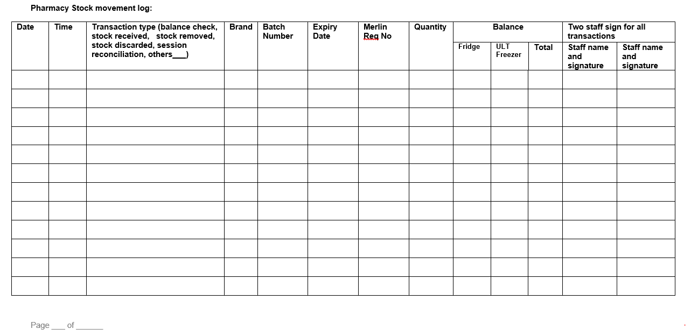

# Appendix 2: WH COVID-19 Vaccine Stock Recording Form at Clinic

Reconciliation of COVID-19 vaccines occurs at four steps in the supply chain: Location: \_\_\_\_\_\_\_\_\_\_\_\_\_\_\_\_\_\_\_\_\_\_\_\_\_\_

* Balance check at the start of a clinic session;
* During receipt of COVID-19 vaccine stock and placement into the vaccine refrigerator in the clinic. Brand: \_\_\_\_\_\_\_\_\_\_\_\_\_\_\_\_\_\_\_\_\_\_\_\_\_\_\_\_
* When COVID-19 vaccine stock is removed from the vaccine refrigerator in the clinic;
* Balance check at the end of the clinic session to account for COVID-19 vaccine usage and wastage.

**Clinical Area Stock movement log:**

|  |  |  |  |  |  |  |  |  |  |  |  |  |  |
| --- | --- | --- | --- | --- | --- | --- | --- | --- | --- | --- | --- | --- | --- |
| **Date** | **Time** | **Transaction type (balance check, stock received, stock removed, stock discarded, session reconciliation)** | **Brand** | **Batch Number** | **Expiry Date** | **Merlin Transaction ID number** | **Quantity** | **Balance** | **Session vaccine reconciliation** | | | **Two staff sign for all transactions** | |
| **Vial usage** | **Vial disposal/ wastage** | **Syringe disposal/ wastage** | **Staff name and signature** | **Staff name and signature** |
|  |  |  |  |  |  |  |  |  |  |  |  |  |  |
|  |  |  |  |  |  |  |  |  |  |  |  |  |  |
|  |  |  |  |  |  |  |  |  |  |  |  |  |  |
|  |  |  |  |  |  |  |  |  |  |  |  |  |  |
|  |  |  |  |  |  |  |  |  |  |  |  |  |  |
|  |  |  |  |  |  |  |  |  |  |  |  |  |  |
|  |  |  |  |  |  |  |  |  |  |  |  |  |  |
|  |  |  |  |  |  |  |  |  |  |  |  |  |  |
|  |  |  |  |  |  |  |  |  |  |  |  |  |  |
|  |  |  |  |  |  |  |  |  |  |  |  |  |  |
|  |  |  |  |  |  |  |  |  |  |  |  |  |  |
|  |  |  |  |  |  |  |  |  |  |  |  |  |  |
|  |  |  |  |  |  |  |  |  |  |  |  |  |  |

# 

# Appendix 3 Pfizer-BioNTech COVID-19 Vaccine Room Temperature Exposure

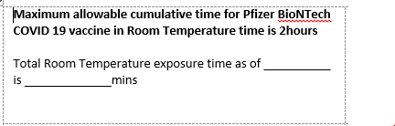

# Appendix 4:

# PPE required when Handling Dry Ice and Vaccines Stored in ULT Conditions

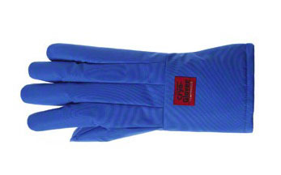

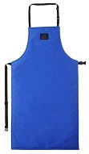 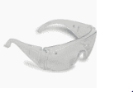

# Appendix 5: COVID-19 Vaccine transportation label

# Pfizer age 12+ COVID-19 Vaccine Pfizer age 5-11 COVID-19 Vaccine

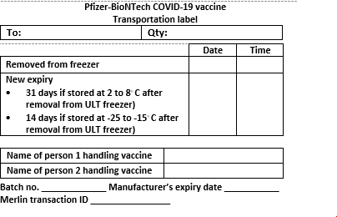

# Moderna COVID-19 Vaccine

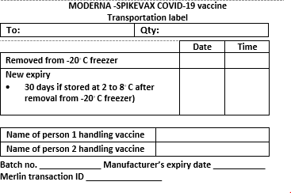

# Appendix 6: Label for Quarantined Temperature Excursion Stock

**DO NOT USE STOCK**

# Appendix 7: Temperature Monitoring Form for Freezers (-80⁰C and -20⁰C)

# WESTERN HEALTH COVID-19 VACCINE (-80⁰C and -20⁰C) FREEZER TEMPERATURE MONITORING CHART

|  |  |  |  |  |  |  |  |
| --- | --- | --- | --- | --- | --- | --- | --- |
| Location of ULT Freezer | JKSAT Pharmacy Storeroom | Month |  | Year |  | Temperature Storage Range of Vaccines |  |

|  |  |  |  |  |  |  |  |  |  |  |  |  |  |  |  |  |  |  |  |  |  |  |  |  |  |  |  |  |  |  |  |  |
| --- | --- | --- | --- | --- | --- | --- | --- | --- | --- | --- | --- | --- | --- | --- | --- | --- | --- | --- | --- | --- | --- | --- | --- | --- | --- | --- | --- | --- | --- | --- | --- | --- |
| **Day** | **1** | | | | **2** | | | | **3** | | | | **4** | | | | **5** | | | | **6** | | | | **7** | | | | **8** | | | |
| **Time** | **0800** | **1100** | **1400** | **1700** | **0800** | **1100** | **1400** | **1700** | **0800** | **1100** | **1400** | **1700** | **0800** | **1100** | **1400** | **1700** | **0800** | **1100** | **1400** | **1700** | **0800** | **1100** | **1400** | **1700** | **0800** | **1100** | **1400** | **1700** | **0800** | **1100** | **1400** | **1700** |
| **Actual**  **Time** |  |  |  |  |  |  |  |  |  |  |  |  |  |  |  |  |  |  |  |  |  |  |  |  |  |  |  |  |  |  |  |  |
| **Staff signature** |  |  |  |  |  |  |  |  |  |  |  |  |  |  |  |  |  |  |  |  |  |  |  |  |  |  |  |  |  |  |  |  |
| **Max temp** |  |  |  |  |  |  |  |  |  |  |  |  |  |  |  |  |  |  |  |  |  |  |  |  |  |  |  |  |  |  |  |  |
| **Current temp** |  |  |  |  |  |  |  |  |  |  |  |  |  |  |  |  |  |  |  |  |  |  |  |  |  |  |  |  |  |  |  |  |
| **Min temp** |  |  |  |  |  |  |  |  |  |  |  |  |  |  |  |  |  |  |  |  |  |  |  |  |  |  |  |  |  |  |  |  |
| **Temp RESET**  **(tick box)** |  |  |  |  |  |  |  |  |  |  |  |  |  |  |  |  |  |  |  |  |  |  |  |  |  |  |  |  |  |  |  |  |

|  |  |  |  |  |  |  |  |  |  |  |  |  |  |  |  |  |  |  |  |  |  |  |  |  |  |  |  |  |  |  |  |  |
| --- | --- | --- | --- | --- | --- | --- | --- | --- | --- | --- | --- | --- | --- | --- | --- | --- | --- | --- | --- | --- | --- | --- | --- | --- | --- | --- | --- | --- | --- | --- | --- | --- |
| **Day** | **9** | | | | **10** | | | | **11** | | | | **12** | | | | **13** | | | | **14** | | | | **15** | | | | **16** | | | |
| **Time** | **0800** | **1100** | **1400** | **1700** | **0800** | **1100** | **1400** | **1700** | **0800** | **1100** | **1400** | **1700** | **0800** | **1100** | **1400** | **1700** | **0800** | **1100** | **1400** | **1700** | **0800** | **1100** | **1400** | **1700** | **0800** | **1100** | **1400** | **1700** | **0800** | **1100** | **1400** | **1700** |
| **Actual**  **Time** |  |  |  |  |  |  |  |  |  |  |  |  |  |  |  |  |  |  |  |  |  |  |  |  |  |  |  |  |  |  |  |  |
| **Staff signature** |  |  |  |  |  |  |  |  |  |  |  |  |  |  |  |  |  |  |  |  |  |  |  |  |  |  |  |  |  |  |  |  |
| **Maximum temp** |  |  |  |  |  |  |  |  |  |  |  |  |  |  |  |  |  |  |  |  |  |  |  |  |  |  |  |  |  |  |  |  |
| **Current temp** |  |  |  |  |  |  |  |  |  |  |  |  |  |  |  |  |  |  |  |  |  |  |  |  |  |  |  |  |  |  |  |  |
| **Minimum temp** |  |  |  |  |  |  |  |  |  |  |  |  |  |  |  |  |  |  |  |  |  |  |  |  |  |  |  |  |  |  |  |  |
| **Temp RESET**  **(tick box)** |  |  |  |  |  |  |  |  |  |  |  |  |  |  |  |  |  |  |  |  |  |  |  |  |  |  |  |  |  |  |  |  |

Page 1 of 2 - continue on next page

|  |  |  |  |  |  |  |  |  |  |  |  |  |  |  |  |  |  |  |  |  |  |  |  |  |  |  |  |  |  |  |  |  |
| --- | --- | --- | --- | --- | --- | --- | --- | --- | --- | --- | --- | --- | --- | --- | --- | --- | --- | --- | --- | --- | --- | --- | --- | --- | --- | --- | --- | --- | --- | --- | --- | --- |
| **Day** | **17** | | | | **18** | | | | **19** | | | | **20** | | | | **21** | | | | **22** | | | | **23** | | | | **24** | | | |
| **Time** | **0800** | **1100** | **1400** | **1700** | **0800** | **1100** | **1400** | **1700** | **0800** | **1100** | **1400** | **1700** | **0800** | **1100** | **1400** | **1700** | **0800** | **1100** | **1400** | **1700** | **0800** | **1100** | **1400** | **1700** | **0800** | **1100** | **1400** | **1700** | **0800** | **1100** | **1400** | **1700** |
| **Actual**  **Time** |  |  |  |  |  |  |  |  |  |  |  |  |  |  |  |  |  |  |  |  |  |  |  |  |  |  |  |  |  |  |  |  |
| **Staff signature** |  |  |  |  |  |  |  |  |  |  |  |  |  |  |  |  |  |  |  |  |  |  |  |  |  |  |  |  |  |  |  |  |
| **Max temp** |  |  |  |  |  |  |  |  |  |  |  |  |  |  |  |  |  |  |  |  |  |  |  |  |  |  |  |  |  |  |  |  |
| **Current temp** |  |  |  |  |  |  |  |  |  |  |  |  |  |  |  |  |  |  |  |  |  |  |  |  |  |  |  |  |  |  |  |  |
| **Min temp** |  |  |  |  |  |  |  |  |  |  |  |  |  |  |  |  |  |  |  |  |  |  |  |  |  |  |  |  |  |  |  |  |
| **Temp RESET**  **(tick box)** |  |  |  |  |  |  |  |  |  |  |  |  |  |  |  |  |  |  |  |  |  |  |  |  |  |  |  |  |  |  |  |  |

|  |  |  |  |  |  |  |  |  |  |  |  |  |  |  |  |  |  |  |  |  |  |  |  |  |  |  |  |  |
| --- | --- | --- | --- | --- | --- | --- | --- | --- | --- | --- | --- | --- | --- | --- | --- | --- | --- | --- | --- | --- | --- | --- | --- | --- | --- | --- | --- | --- |
| **Day** | **25** | | | | **26** | | | | **27** | | | | **28** | | | | **29** | | | | **30** | | | | **31** | | | |
| **Time** | **0800** | **1100** | **1400** | **1700** | **0800** | **1100** | **1400** | **1700** | **0800** | **1100** | **1400** | **1700** | **0800** | **1100** | **1400** | **1700** | **0800** | **1100** | **1400** | **1700** | **0800** | **1100** | **1400** | **1700** | **0800** | **1100** | **1400** | **1700** |
| **Actual**  **Time** |  |  |  |  |  |  |  |  |  |  |  |  |  |  |  |  |  |  |  |  |  |  |  |  |  |  |  |  |
| **Staff signature** |  |  |  |  |  |  |  |  |  |  |  |  |  |  |  |  |  |  |  |  |  |  |  |  |  |  |  |  |
| **Maximum temp** |  |  |  |  |  |  |  |  |  |  |  |  |  |  |  |  |  |  |  |  |  |  |  |  |  |  |  |  |
| **Current temp** |  |  |  |  |  |  |  |  |  |  |  |  |  |  |  |  |  |  |  |  |  |  |  |  |  |  |  |  |
| **Minimum temp** |  |  |  |  |  |  |  |  |  |  |  |  |  |  |  |  |  |  |  |  |  |  |  |  |  |  |  |  |
| **Temp RESET**  **(tick box)** |  |  |  |  |  |  |  |  |  |  |  |  |  |  |  |  |  |  |  |  |  |  |  |  |  |  |  |  |

I**f the temperature is outside the recommended range, complete the table on the following page and contact the COVID 19 Pharmacy Project Officer, Senior Clinical Trials Pharmacist and Director of Pharmacy immediately.**

**Instructions for use:**

* For Pfizer BioNTech COVID-19 Vaccine Freezer, record maximum and minimum of temperature **FOUR times a day, at 0800, 1100, 1400 and 1700**

Page 2 of 2

# COVID-19 Vaccine Storage Troubleshoot Sheet

|  |  |  |  |  |  |  |
| --- | --- | --- | --- | --- | --- | --- |
| **Date** | **Time** | **Max./min. temperatures** | **Problem** | **Action taken** | **Results** | **Initials** |
|  |  |  |  |  |  |  |
|  |  |  |  |  |  |  |
|  |  |  |  |  |  |  |
|  |  |  |  |  |  |  |
|  |  |  |  |  |  |  |
|  |  |  |  |  |  |  |
|  |  |  |  |  |  |  |
|  |  |  |  |  |  |  |
|  |  |  |  |  |  |  |
|  |  |  |  |  |  |  |
|  |  |  |  |  |  |  |
|  |  |  |  |  |  |  |
|  |  |  |  |  |  |  |
|  |  |  |  |  |  |  |
|  |  |  |  |  |  |  |
|  |  |  |  |  |  |  |
|  |  |  |  |  |  |  |

# Appendix 8:

**ULT Freezer Schedule, Transaction & Temperature Log**

**ULT FREEZER SCHEDULE for week starting:**

|  |  |  |  |  |  |  |
| --- | --- | --- | --- | --- | --- | --- |
|  | **MORNING** | | **MIDDAY** | | **EVENING** | |
|  | **TIME** | **REASON**, e.g. stock  receipt | **TIME** | **REASON**, e.g. packing  deliveries | **TIME** | **REASON**, e.g. thawing  vials |
| **MONDAY** |  |  |  |  |  |  |
| **TUESDAY** |  |  |  |  |  |  |
| **WEDNESDAY** |  |  |  |  |  |  |
| **THURSDAY** |  |  |  |  |  |  |
| **FRIDAY** |  |  |  |  |  |  |
| **SATURDAY** |  |  |  |  |  |  |
| **SUNDAY** |  |  |  |  |  |  |

**ULT FREEZER SHOULD ONLY BE OPENED AT SCHEDULED TIMES.**

**ULT FREEZER TRANSACTION & TEMPERATURE LOG**

**KEEP THE DOOR CLOSED FOR AT LEAST TWO HOURS BETWEEN TRANSACTIONS**

|  |  |  |  |  |  |  |  |  |  |  |  |
| --- | --- | --- | --- | --- | --- | --- | --- | --- | --- | --- | --- |
| **Date** | **Time** | **Transaction type**   * TEMPERATURE RECORD at start & end of day (no. of vials N/A, single sign) * Door OPENED or Door CLOSED (no. of vials N/A; record total time door opened in comments) * Vials IN or OUT | **No. of** **vials IN** | **No. of vials OUT** | **Balance of vials in ULT**  **freezer** | **Name of 1st person** | **Sign** | **Name of 2nd person** | **Sign** | **Temperature** (Prior transaction / after transaction) | **Total time door opened**  (e.g. 2 minutes) |
|  |  |  |  |  |  |  |  |  |  |  |  |
|  |  |  |  |  |  |  |  |  |  |  |  |
|  |  |  |  |  |  |  |  |  |  |  |  |
|  |  |  |  |  |  |  |  |  |  |  |  |
|  |  |  |  |  |  |  |  |  |  |  |  |
|  |  |  |  |  |  |  |  |  |  |  |  |
|  |  |  |  |  |  |  |  |  |  |  |  |
|  |  |  |  |  |  |  |  |  |  |  |  |
|  |  |  |  |  |  |  |  |  |  |  |  |
|  |  |  |  |  |  |  |  |  |  |  |  |
|  |  |  |  |  |  |  |  |  |  |  |  |
|  |  |  |  |  |  |  |  |  |  |  |  |
|  |  |  |  |  |  |  |  |  |  |  |  |
|  |  |  |  |  |  |  |  |  |  |  |  |
|  |  |  |  |  |  |  |  |  |  |  |  |
|  |  |  |  |  |  |  |  |  |  |  |  |
|  |  |  |  |  |  |  |  |  |  |  |  |
|  |  |  |  |  |  |  |  |  |  |  |  |
|  |  |  |  |  |  |  |  |  |  |  |  |
|  |  |  |  |  |  |  |  |  |  |  |  |
|  |  |  |  |  |  |  |  |  |  |  |  |
|  |  |  |  |  |  |  |  |  |  |  |  |
|  |  |  |  |  |  |  |  |  |  |  |  |
|  |  |  |  |  |  |  |  |  |  |  |  |

# Appendix 9:

#### WASTED or DISCARDED COVID-19 VACCINE SYRINGE AND VIAL Recording Tool

|  |  |  |  |  |  |  |  |  |  |  |  |  |
| --- | --- | --- | --- | --- | --- | --- | --- | --- | --- | --- | --- | --- |
| **Date** | **Time** | **Reason for wasted or discarded syringe or Vial**  e.g. expired, discoloured, particulate matter, insufficient remaining vaccine volume in vial | **Batch no.**  **and**  **Expiry** | **Quantity wasted or discarded** | | **Cumulative total** | | **Method of Disposal** | **Name of 1st person** | **Signature** | **Name of 2nd person** | **Signature** |
| Syringe | Vial | Syringe | Vial |
|  |  |  |  |  |  |  |  |  |  |  |  |  |
|  |  |  |  |  |  |  |  |  |  |  |  |  |
|  |  |  |  |  |  |  |  |  |  |  |  |  |
|  |  |  |  |  |  |  |  |  |  |  |  |  |
|  |  |  |  |  |  |  |  |  |  |  |  |  |
|  |  |  |  |  |  |  |  |  |  |  |  |  |
|  |  |  |  |  |  |  |  |  |  |  |  |  |
|  |  |  |  |  |  |  |  |  |  |  |  |  |
|  |  |  |  |  |  |  |  |  |  |  |  |  |
|  |  |  |  |  |  |  |  |  |  |  |  |  |
|  |  |  |  |  |  |  |  |  |  |  |  |  |
|  |  |  |  |  |  |  |  |  |  |  |  |  |
|  |  |  |  |  |  |  |  |  |  |  |  |  |
|  |  |  |  |  |  |  |  |  |  |  |  |  |
|  |  |  |  |  |  |  |  |  |  |  |  |  |
|  |  |  |  |  |  |  |  |  |  |  |  |  |
|  |  |  |  |  |  |  |  |  |  |  |  |  |
|  |  |  |  |  |  |  |  |  |  |  |  |  |
|  |  |  |  |  |  |  |  |  |  |  |  |  |
|  |  |  |  |  |  |  |  |  |  |  |  |  |
|  |  |  |  |  |  |  |  |  |  |  |  |  |

###### Report daily total of wasted syringes to Vaccination Clinic Nurse Unit Manager

# Appendix 10: COVID-19 Vaccine Order Form

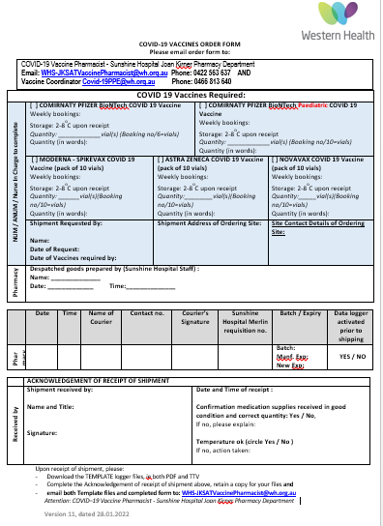

# Appendix 11: Manufacturing Cards for COVID-19 Vaccines

**Manufacturing Card Pfizer age 12+ COVID-19 Vaccine**

|  |  |  |  |
| --- | --- | --- | --- |
| **Date:** | **Thawed Exp:** | | **Name:** |
| **Batch #** | **Manuf Exp:** | |  |
| **Operator Type:** | | **P T SP RN SN** | |
| **Time out of Fridge:** | |  |  |
| **NaCl Batch & Exp:** | |  |  |
| **Dilution Time:** | |  |  |
| **New Expiry:** | |  |  |
| **Number of Doses Drawn:** | |  |  |
| **Number of Doses Released:** | |  |  |
| **Time Checked:** | |  |  |
| Notes: | | | |
| **WH Manufacturing Batch #:** | |  | |

|  |  |  |  |
| --- | --- | --- | --- |
| **Date:** | **Thawed Exp:** | | **Name:** |
| **Batch #** | **Manuf Exp:** | |  |
| **Operator Type:** | | **P T SP RN SN** | |
| **Time out of Fridge:** | |  |  |
| **NaCl Batch & Exp:** | |  |  |
| **Dilution Time:** | |  |  |
| **New Expiry (12 hours):** | |  |  |
| **Number of Doses Drawn:** | |  |  |
| **Number of Doses Released:** | |  |  |
| **Time Checked:** | |  |  |
| Notes: | | | |
| **WH Manufacturing Batch #:** | |  | |

**Manufacturing Card Age 5-11 Pfizer COVID-19 Vaccine**

**Manufacturing Card AstraZeneca COVID-19 Vaccine**

|  |  |  |
| --- | --- | --- |
| **Date:** | | **Name:** |
| **Batch #: Exp:** | |  |
| **Operator Type:** | **P T SP RN SN** | |
| **Time out of Fridge:** |  |  |
| **New Expiry (6hrs after removal from fridge)** |  |  |
| **Number of Doses Drawn:** |  |  |
| **Number of Doses Released:** |  |  |
| **Time Checked:** |  |  |
| **Issues Identified** (Code): |  | |
| Notes: | | |
| **WH Manufacturing Batch #:** |  | |

|  |  |  |
| --- | --- | --- |
| **Date: / /21 Thawed exp: / /21** | | **Name:** |
| **Batch #: 000016A Mf exp: 26/03/2022** | |  |
| **Operator Type:** | **P T SP RN SN** | |
| **Time out of Fridge:** |  |  |
| **New Expiry (6hrs after removal from fridge)** |  |  |
| **Number of Doses Drawn:** |  |  |
| **Number of BOOSTERS Drawn:** |  |  |
| **Number of Doses Released:** |  |  |
| **Time Checked:** |  |  |
| **Issues Identified** (Code): |  | |
| Notes: | | |
| **WH Manufacturing Batch #:** | 21 (p1) | |

**Manufacturing Card Moderna COVID-19 Vaccine**

|  |  |  |  |
| --- | --- | --- | --- |
| **Number of full doses drawn** | **Number of BOOSTERS drawn** | **OUTREACH/INREACH** | **Time left under room temp** |
|  |  |  |  |
|  |  |  |  |
|  |  |  |  |
|  |  |  |  |
|  |  |  |  |
|  |  |  |  |
|  |  |  | (p2) |

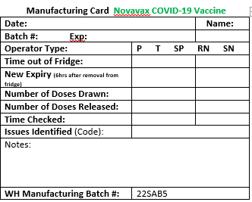

# Appendix 12: PHARMACY DAILY LOG

# PHARMACY LOG – Pfizer age 12+ COVID-19 VACCINE (mRNA BTN 162B2)

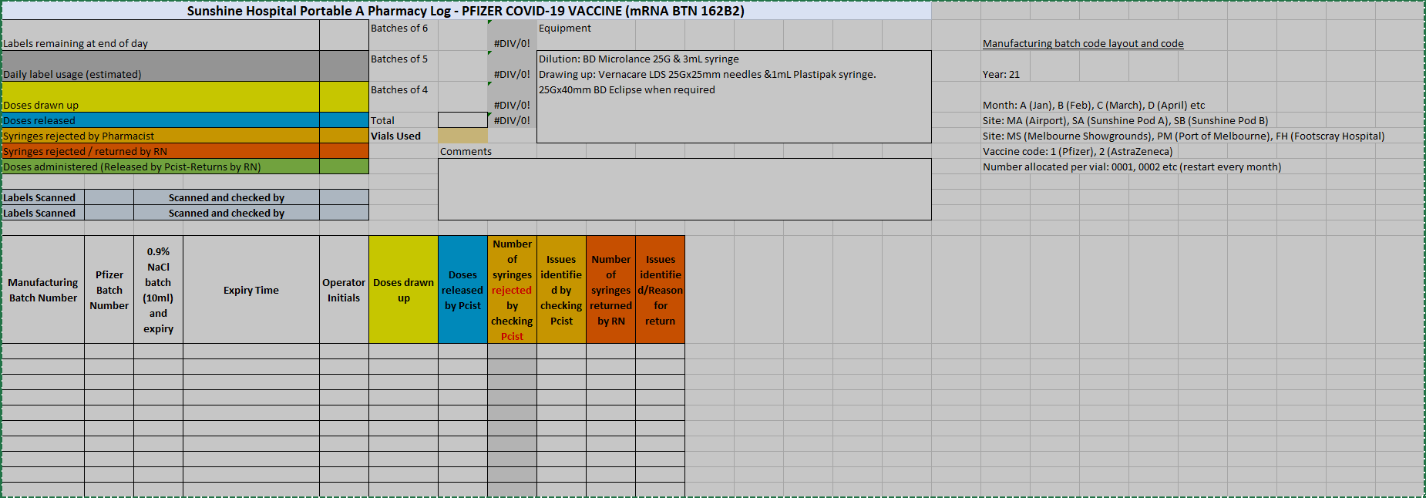

# PHARMACY LOG – Pfizer age 5-11 COVID-19 VACCINE (Tozinameran)

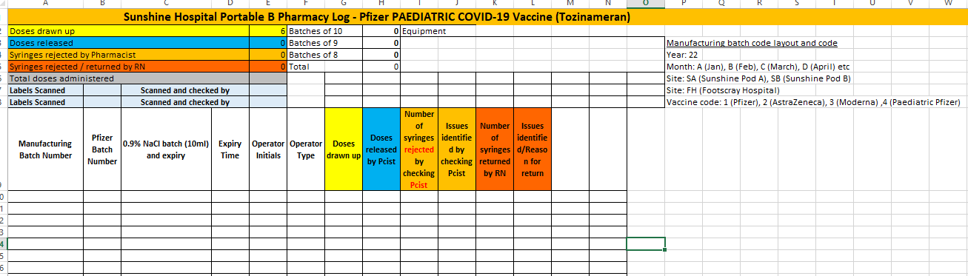

|  |
| --- |
| PHARMACY LOG - AstraZeneca COVID-19 VACCINE (ChAdOx1-S) |

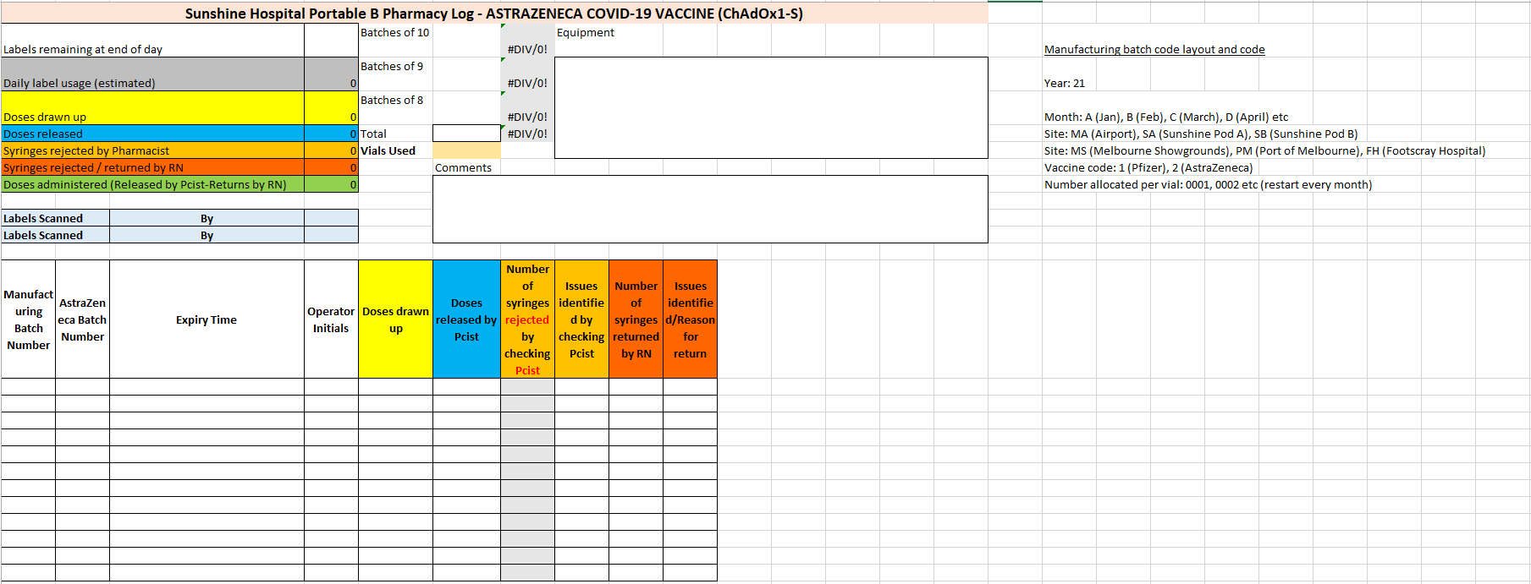

# PHARMACY LOG - Moderna COVID-19 VACCINE (Elasomeran)

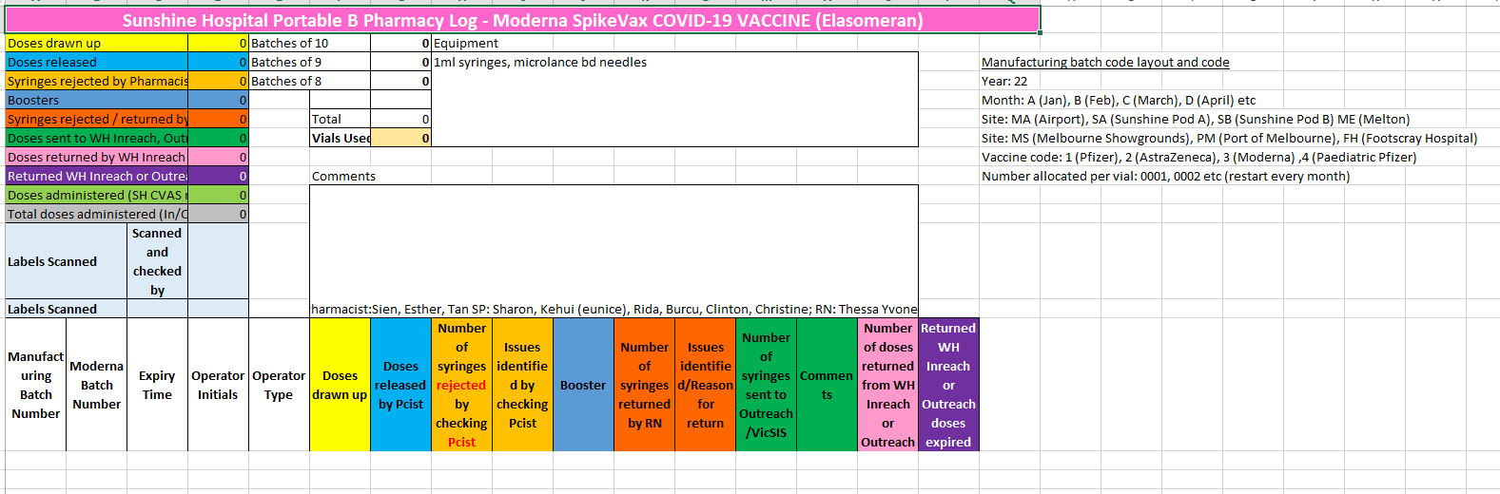

# PHARMACY LOG - Novavax COVID-19 VACCINE (SARS-CoV-2 rs NVX-CoV2373)

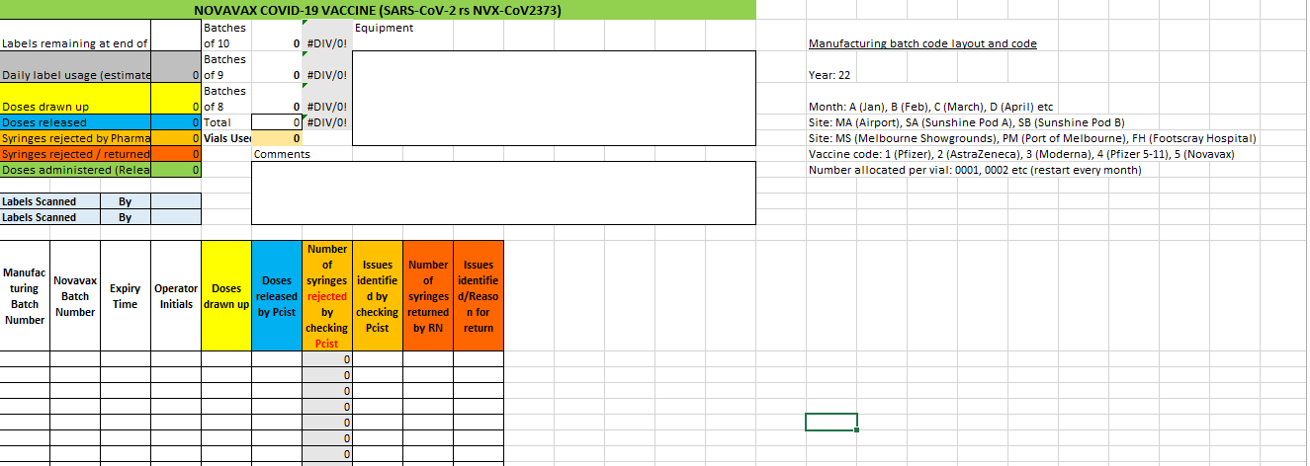

# Appendix 13: FREEZER MAP

Freezer Map on wall with Pfizer Vaccine tray details and quantity Photo of Freezer shelves

# C:\Users\yeohl\AppData\Local\Microsoft\Windows\INetCache\Content.Outlook\U5NE08OE\20210511_114049_resized.jpg S:\pharmacy1\COVID 19 Vaccination Project\Forms and Templates\Freezer Stock Mapping Template\Freezer template (image).png

# Appendix 14: TIVE 5 Logger

Website: <https://platform.tive.io/>

User: WHS-JKSATVaccinePharmacist@wh.org.au

Password: Pharmacy1!

Example shipment:

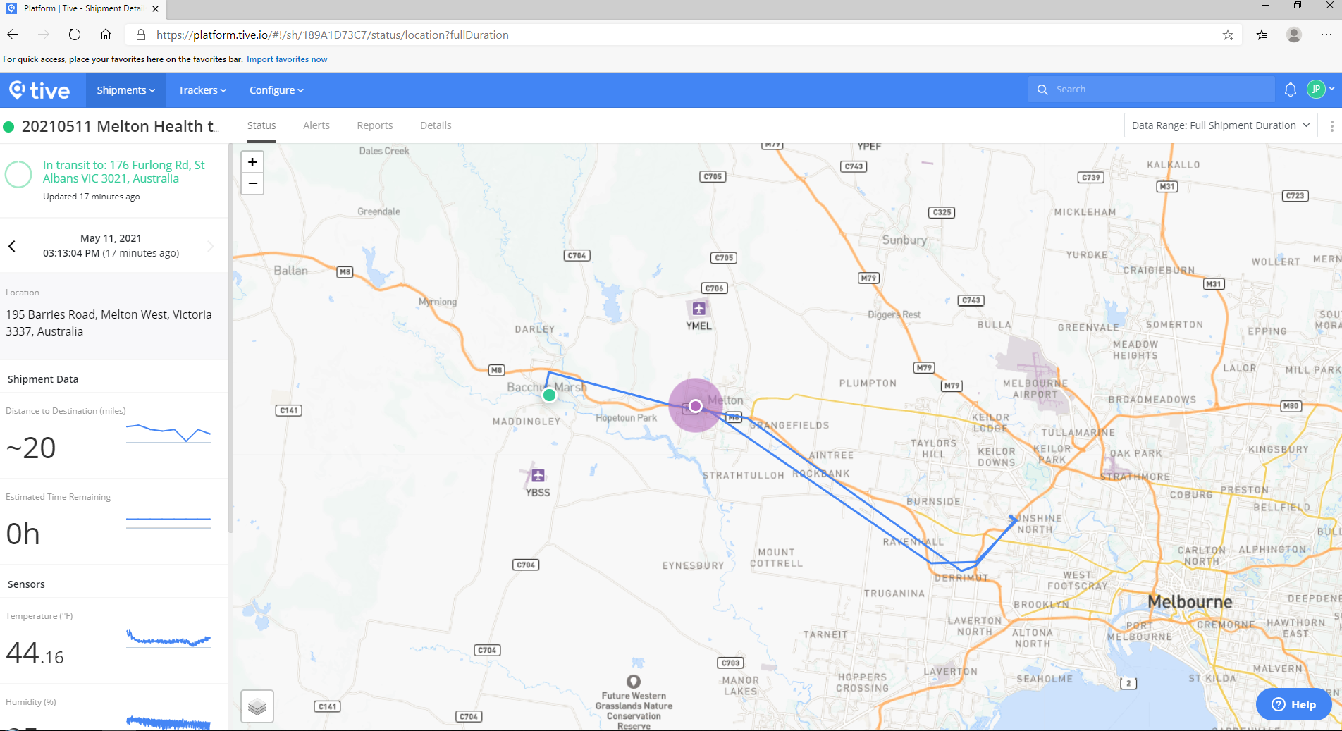

Sample screens:

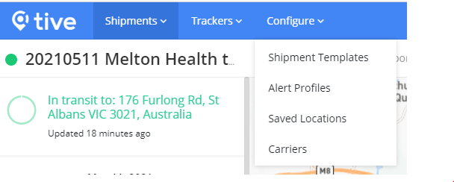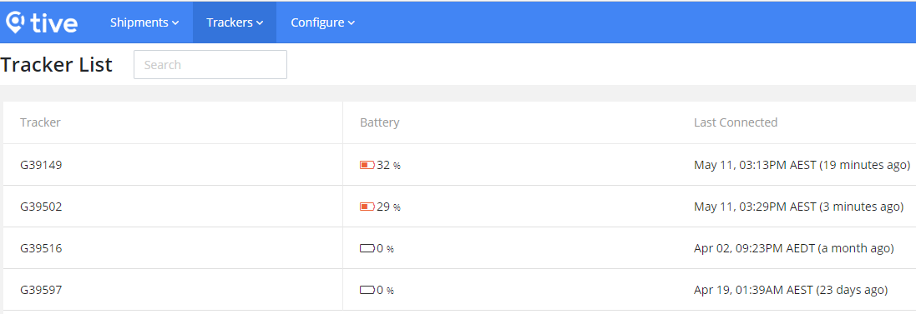

Available TIVE 5 devices at JKSAT Pharmacy:

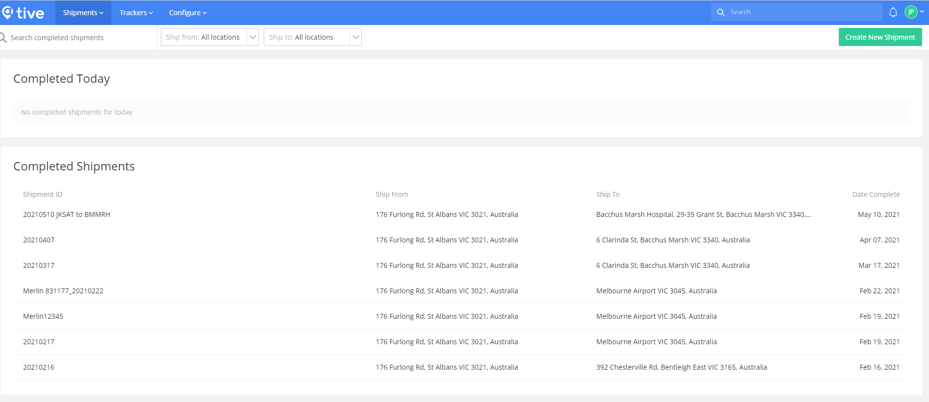

# Appendix 15: Coldtainer – for vaccine storage at remote vaccination sites (e.g. RACF)

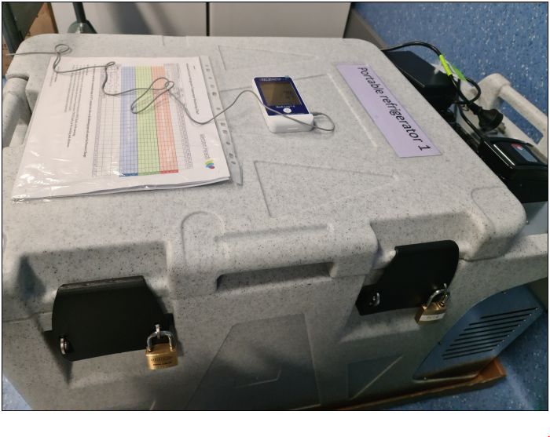 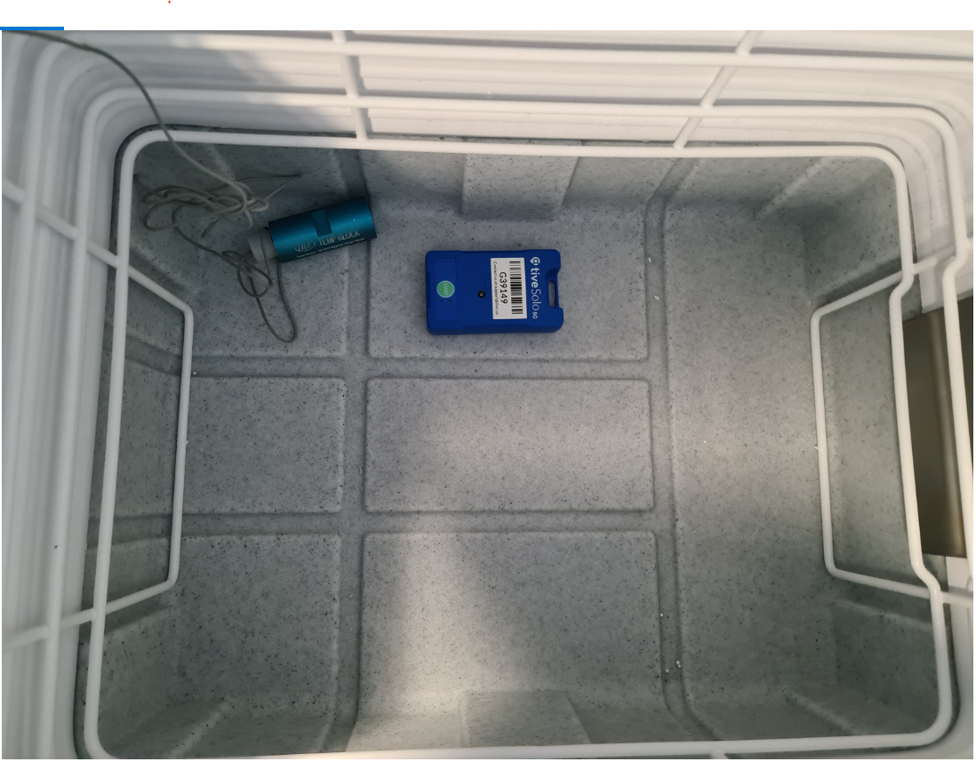

Medilog II for temperature tracking

Place TIVE 5 logger inside the Coldtainer for GPS and temperature tracking

padlocks